Life in the Universe

Ever since mankind has been contemplating the heavens, people have thought about what aliens might be out there. Even the Greeks had aliens of sorts in their writings. In the 16th century, Bruno suggested that every star had planets and life (the first to conceptualize the universe this way, he was eventually burned at the stake, though not solely for this view).

Later, when Percival Lowell used his telescope to look at Mars, he even imagined he saw canals signifying life (partly due to a mistranslation of Schiaparelli's canali, which means channels, not canals). Of course, the human brain is very good at drawing connections where they don't really exist, and today we know that those “canals” were just the human eye connecting unrelated features.

Of course, whether or not planets actually exist around other stars was an open question until we started detecting them. At first, we could only find planets that were very large – bigger than Jupiter – and very close to their parent stars. These huge, hot gaseous planets aren't especially good for life as we know it. However, as our technology improves, we find more planets – recently even planets and stellar systems similar to our own Solar System. We are beginning to have evidence that Bruno was more or less correct: while not all stars have planets around them, many probably do.

Today, what we know about other planets in our solar system, as well as life here on Earth, lets us imagine what life might be like on planets around other stars. In this lab, you will think about the question: If there is other intelligent life out there... why haven't we heard from them?
Part 1: The Drake Equation

In the early 1960's, astronomer Frank Drake tried to address the question of how much life there is in the universe. He proposed a calculation that estimates the number of civilizations that we might make contact with in the galaxy. His equation is:

N = pn_{e}R*L

where p = f_{p}f_{l}f_{i}f_{c}

N = number of civilizations we might be able to contact
R* = average rate of star formation (stars per year)
L = average lifetime that a civilization is technologically active
n_{e} = average number of Earth-like planets per solar system

In this lab you will make estimates for R*, L and n_{e}.

In addition, we will use estimates for the factors that make up p:
f_{p} = average fraction of stars which have planets
f_{l} = average fraction of Earth-like planets with life
f_{i} = average fraction of Earth-like planets with at least one
intelligent species
f_{c} = average fraction of Earth-like planets with civilizations
capable of interstellar communication

Typical values that are used are f_{p} = 0.5, f_{l} = 1, f_{i} = 0.1, f_{c} = 0.1, which gives a value for p = 0.005.

The fun and power of the Drake Equation comes not in the answer we obtain, but rather in the questions that are stimulated in an attempt to arrive at that answer. Let's think about some of those questions now:

1. By emphasizing "Earth-like" planets, what assumptions are we making about life in the Universe?

2. The life bearing, "garden-like" state of the Earth is the result of many fortunate circumstances. What are some of the things that we believe life needs to survive? List as many as you can think of. Try to be as general as possible: just because some animals eat plants, does not mean that all life needs plants to survive (otherwise how would life have originally started?)

3. Even within our own solar system some of the basic assumptions might be circumvented. Titan and Europa (both moons) both might be possibilities for life. What do you think n_{e} is for our Solar System?

4. Given your answers to #2 and #3, would the average value of n_{e} for other solar systems be equal to, more, or less than the value you gave for our own Solar System? Why?

5. There are at least 10¹¹ (some say the number is as high as 6×10¹¹) stars in the Milky Way galaxy and the galaxy is about 10¹⁰ years old. Estimate a value for the star formation rate, R* (the number of stars formed per year).

6. L is the average lifetime for an advanced civilization, which we will say begins with the ability to use radio communication.

a. Give reasons why L might be on the order of hundreds of years (a short lived civilization). What would a civilization have to be like to have a L value in the thousands or greater (a long lived civilization)?

b. Give your own estimate for L and the reasoning behind it.

c. By this definition, how long has our society been advanced?

7. Using your estimates of R*, L, and n_{e}, and the given value for p, compute your value of N.

Part 2: Colonizing the Milky Way Galaxy

Imagine that a very technologically advanced civilization with the capability of interstellar travel develops on a planet somewhere in the Milky Way galaxy. They decide to commit their resources to spreading their race and civilization across the Galaxy. With advanced instruments and telescopes, they locate two stars, each about 100 light years away, that have planets that might be habitable. They send an unmanned probe to each, and the probes report back that indeed there is a habitable planet in each system.

1. They decide to send a colony ship to each planet. Their starships and unmanned probes travel at 1/100th the speed of light. The unmanned probes can send a radio signal back to the parent planet at the speed of light.

- Give the speed of light, in units of light-years per year:

b. How many years will it take the unmanned probe to travel 100 light-years?

c. What is the unmanned probe travel time + signal travel time?

d. Now that the probe has returned its information, what will be the travel time of the colony ship?

The prime directive of the colonies is to develop the new planet and when they have sufficient resources (mines and refineries), infrastructure (roads and politicians), and have found new candidate planets for the next generation of colonies, to send out their own probes to other systems.
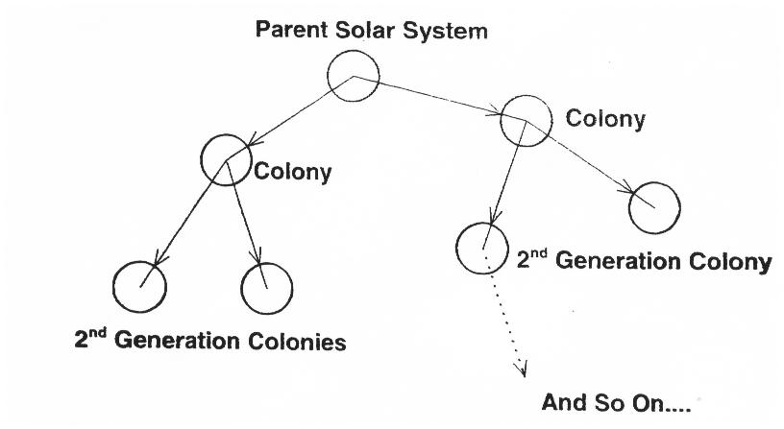
2. Estimate how long it will take a colony to develop the planet they landed on and their civilization to the point where they can set off to colonize two new planets. Do they start from scratch (a crash landing, for example) or start with all of the technological knowledge of the parent civilization? The new planet may have to be terraformed, etc. and don't forget you have to send new probes! List separate stage of development for the colony and estimate how long each stage will last. Be as detailed as possible.

Development Stage Length of Time for Stage

3. What is the total time from launch of a colony ship to the point where the next colony is launching its ships? (Hint: be sure to include development time from #2, travel, and signal time for another probe)

4. How long will it take this race of intelligent beings to spread across the galaxy? To do this calculation, follow only one string of colonies. You may assume that the colonies travel straight across the galaxy. The Milky Way is about 100,000 light years across.

5. The Sun and our Solar System are about 4.5 billion years old. The Galaxy is at least twice that old. How many times could they have crossed the Galaxy in that time? Should they have been here by now?

6. Develop at least three reasons why we have not been colonized.

Part 3: The Infosphere

Our information sphere is the region of space in which our radio signals have had time to reach. It is within this volume that another civilization would have to be in order for them to discover us at this point in our development. Similarly, in order to detect another civilization, we must be within their information sphere.
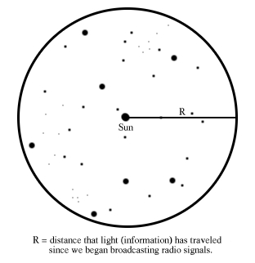
1. Using your number for how long we have been an advanced civilization (from Part 1), what is the radius and volume of our information sphere?
Hint: the volume of a sphere is given by , so your answer should be in light-years³.

2. Given that the average density of stars in the "solar neighborhood" is 1 star per 30 light-years³, what is the number of stars in our information sphere?

3. From what year of Earth’s radio broadcasts would each of the following stars be receiving right now? Would they be receiving any broadcasts from us now?

a) Alpha Centauri (Rigil Kentaurus) 4 ly

b) Alpha Lyrae (Vega) 25 ly

c) Alpha Geminorum (Castor) 52 ly

d) The center of the galaxy (8.5 kpc away)
(hint: 1 pc = 3.26 light-years)

4. If you get satellite TV or use a GPS, your signal comes from a satellite. Estimate how much total power we emit into space using:
- Power emitted by one satellite: 50 Watts (most are less)
- Number of working satellites: about 560
- Percentage of power that goes away from Earth (remember they are designed to emit toward Earth: choose your own reasonable percentage.

5. The strength of a broadcast light signal decreases as 1/r². What would the flux be by the time it reaches Alpha Centauri, in W/m²?
(1 light year = 9.5 x 10¹⁵ m)

6. The galactic background has a flux between 10⁻²¹ to 10⁻²⁰ W/m². If there are intelligent civilizations out there, could they detect our radio emissions? Why or why not?

7. Draw an alien! (if you have time)

