Expansion of the Universe

As our telescopes get more sensitive, we can find fainter and fainter objects – and we find that the universe is filled with galaxies. Not even 100 years ago,
we thought that the whole universe was filled with stars, and that all of the fuzzy blobs we saw were objects between the stars.

In 1920, a big debate between Shapley and Curtis tried to “solve” the question of what those fuzzy nebulae were. Shapley thought that the Milky Way was the entire universe; Curtis on the other hand thought that some of those fuzzy blobs were “island universes” in their own right. Shapley handily won the debate – but in the end it turned out he was wrong. A few years after the debate, Hubble made observations using Henrietta Swan Leavitt's period-luminosity relation for Cepheids. His observations showed that they were much too distant to be within the Milky Way.

Hubble combined his observations with those of Vesto Silpher, who had discovered that the galaxies' spectra were Doppler shifted relative to spectra observed in the laboratory. Recall that for objects moving away from us the wavelengths of emitted light are stretched so that we observe longer redder wavelengths. Similarly, objects moving toward us compress the wavelengths so that they appear bluer. By measuring the amount of wavelength shift we can determine the speed and direction the galaxies are moving. Hubble compared the velocities of the galaxies to their distance and discovered that the further the galaxy was, the faster it was moving away from us!

The distance-velocity relation discovered by Hubble arises naturally in a universe that is expanding. If the space between any two points in space is getting larger, the velocity of their separation will be proportional to their distance. If we run the clock backwards, we find that at some point in the distant past all the galaxies we see in the universe were all in the same place – Big Bang. In today's lab, you are going to follow in Hubble's footsteps to determine how long ago the Big Bang occurred.

Classifying Galaxy Spectra

In order to explore the idea of Doppler shifted spectra we are going to use galaxy spectra from the Zooniverse website. Modern images and spectra of galaxies are obtained on digital cameras and computer processed.

- Open the Zooniverse Website tinyurl.com/ast1001 and click on Hubble’s Law in the upper right corner to scroll down.

- Click on the “Project page” link to access the galaxy spectrum classification activity. Select “University of St. Thomas”. (If not there, click on “Get Started” and then St. Thomas.)

You’ll be presented with a galaxy spectrum. There are a few things to notice about it. As usual for a spectrum, the graph is intensity vs. wavelength (in nanometers here, or 10⁻⁹ m). You see a continuum, which generally slopes upward. This is because a galaxy is made up of stars, and there are many more red stars than blue ones, so you see more red light than blue.

You also see a few absorption lines. Every atom has its own fingerprint, a special spacing of spectral lines. The lines we are interested in are the two that are close together. Your task is to mark the location of the Calcium K-line (the left, or shorter wavelength line), in the calcium doublet: If you need help to classify a spectrum, you can see some examples by clicking the “Need some help with this task?” button on the right side of the page.

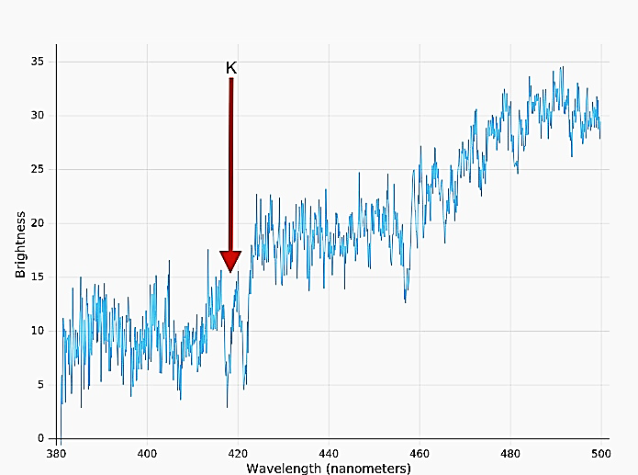

- To get started, click on the drawing tool button:

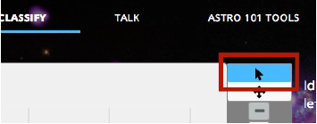

- Click once on the image to get two vertical lines, then move them to the center of the Calcium K line. You can move them both by clicking and in between the lines, and you can move an individual line by grabbing the small dot at its center and dragging right or left.

- Center the box on the Calcium K line. Try to enclose the whole line in the box. You can zoom with the +/- buttons for a better view, and you can change the width of the box with the round handles. Click “Done” once you are happy with your placement of the box. Classify 10 galaxy spectra (you can of course do more if you wish!).

- While you wait for the data, answer question 1 in the packet.

Part 2: Data Analysis
Your instructor will tell you when the aggregated data is ready. When it is, go to http://bit.ly/2pAtLNl and make a copy into your own google drive. Note the columns of data provided for each galaxy:
- Galaxy ID: The galaxy’s catalog number
- RA & Dec: location in the sky
- Dist (Mpc): distance in Megaparsecs
- lambda_av (nm): class average of wavelength for the Calcium K line in nanometers
- lambda_err (nm): standard deviation of the wavelength measurement

We can use this data to measure is how fast the galaxies are moving toward or away from us using the Doppler shift. The actual wavelength (at rest) of the Calcium H line is
λ_{rest} = 393.37 nanometers.

  - Answer questions 2-3 in the answer packet.

  - Create a new column in the spreadsheet to calculate the Doppler Shift of the Calcium K line using the following formula:
Δλ = λ_{observed} – λ_{rest}
NOTE: use the lambda_av column not the lambda_err column!

  - Now create a column to calculate the velocity of the galaxies by using the Doppler shift formula:
velocity = Δλ*c / λ_{rest}
where c is the speed of light, 3 x 10⁵ km/s.

  - To see the relationship to your Research Project also add a column to the spreadsheet for redshift. You can do this by dividing your velocity by the speed of light above.
$$redshift = z = \frac{Δλ}{λ_{0}}=\frac{v}{c}$$
  - Answer question 4 before going on to Part 3.

Part 3: The Hubble Law

Hubble had both distance and velocity information, and like any good astronomer, decided to graph one versus the other. Since he wanted to find out if there was any consistent thing he could see as the galaxies got further away, he graphed velocity vs. distance.

- Using your Zoo Tools, graph velocity (y-axis) vs. distance (x-axis).

- Answer questions 5 through 7 in the answer packet.

- Now add a linear trend line to your plot. To do this:
- In the Scatter Plot Helper window on the right of your screen or using the eye in the upper right corner of your plot in the sheet.
- Hover over the line to see the equation of your fitted line. The slope in this equation is called Hubble’s Constant (H₀). (Recall the equation for a line is y = mx + b where m is the slope and b is the y-intercept.)

- Answer questions 8 through 11 in the answer packet.

The current WMAP results combined with other cosmological data give a best estimate for the Hubble Constant of 70.4 ± 1.4 (km/sec)/Mpc.

- It’s useful to compare your values to the accepted values. Calculate the maximum and minimum accepted values for H₀ and answer question 12.

But what does it mean?

Take a look again at your units of H₀. If you convert your km to Mpc, what are the units of H₀? 1 Megaparsec = 3.086 x 10¹⁹ km. You will also want to convert from seconds to Gigayears (billion years). 1 Gyr = 3.15 x 10¹⁶ seconds.

You are left with H₀ = 1/time. What “time” might that be?

Answer the remaining questions in the packet to find out!

https://map.gsfc.nasa.gov/universe/bb_tests_exp.html

