Images in Astronomy

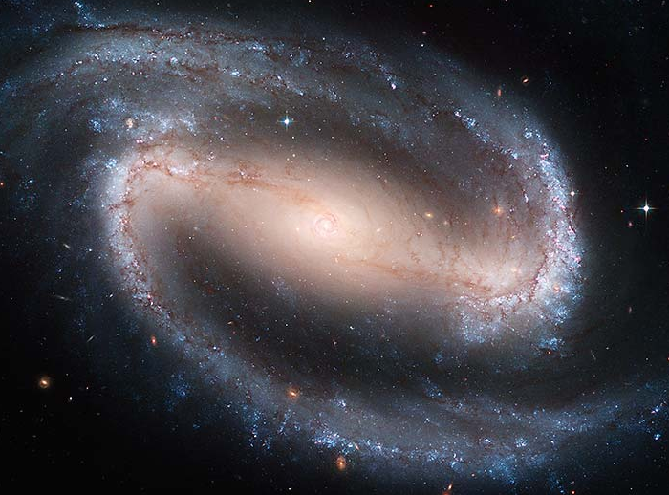
As we've seen in this course, astronomers take pictures of interesting objects to learn more about them. Sometimes, these pictures are spectra, spreading out each wavelength and measuring the intensity to find out information such as the temperature (looking at the blackbody), or to find out what elements are present. Other times, however, astronomers literally take a picture of the object.

The images that astronomers take, even if pretty pictures, also have a whole host of information in them. We take pictures in different colors (even colors beyond our own ability to see, such as radio or ultraviolet) because those pictures give us insight into different physics going on in the object. One useful thing that we can get from looking at pictures of lots of other galaxies is a sense of what our own Milky Way looks like. It's hard to figure out what our own galaxy looks like because we are sitting in the middle of it. It'd be like trying to figure out what your house looks like, if you'd never gone outside of it, by looking out the window at other houses in the neighborhood.

When we look out at the universe beyond the Milky Way, we find many galaxies. The more sensitive our instruments get, the more galaxies we find. When Hubble was observing the galaxies in the 1920s, he came up with a classification scheme based on their appearance. We call this a morphological classification. Biologists use it as well, with animals and plants (does it have five leaves? Six? Are they opposite each other or alternating one side then the other?) Today, we have even better images than Hubble did. You will use some to come up with your own classification and then compare it to Hubble's classification.

You will also use the images you took with the observatory to get a feel for how astronomers make the images you see in the news. Once you've made your image, you will use it to classify your galaxy using the schema you created, and as well as Hubble's original classification.
Part 1: Classification Schemas

You have been given a set of numbered cards with galaxy images on them. Examine these images carefully and use them to devise a system of classification.

- Look for three (or more) obvious features of the galaxies (not all galaxies have to have them) that you might use to sort them.

- Sort the galaxies into two or three groups based on the features that you chose.

- Within each group, arrange the galaxies into a sequence.

- Answer the questions in the answer packet.

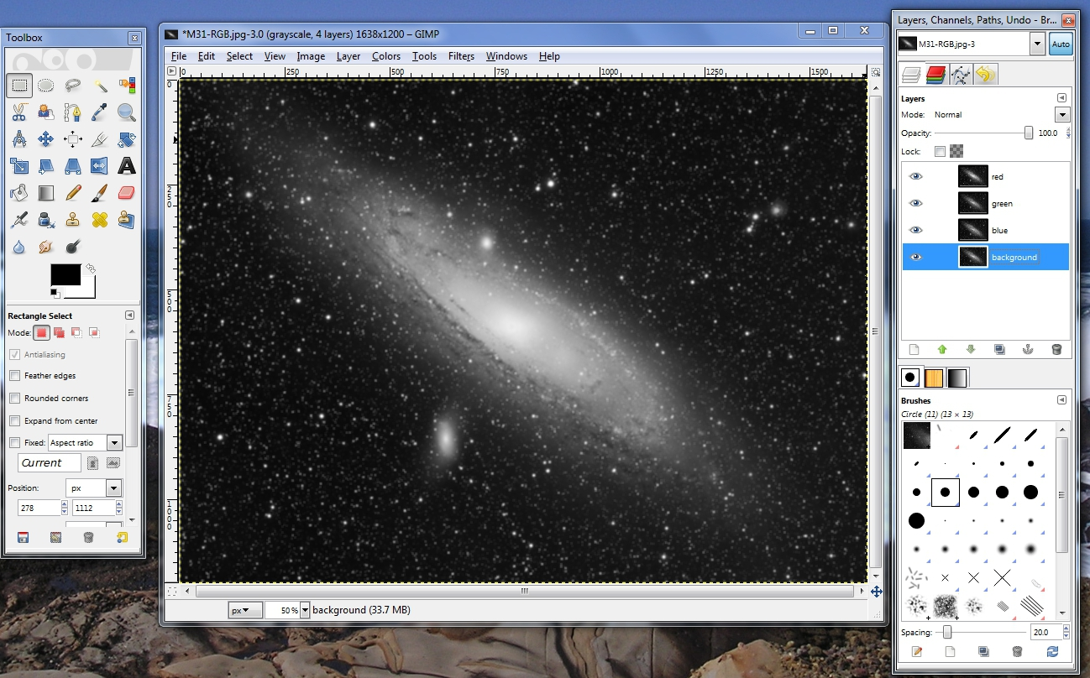
Part 2: Creating and Using Astronomical Images

Now that you have a classification schema for your galaxies, we can use it to classify the galaxy you imaged with the telescope. To do this, we first have to make the image into a pretty color picture.


To do this, we will be using GIMP (Gnu Image Manipulation Program), a free image processing program. Click on the GIMP icon on the desktop. This brings up two windows, the toolbox, and a box where the files will load.

If the Layers dialog box is not already open, go to Windows → Dockable Dialogs → Layers.

Now you will need to open up your images. These are located on the class website in the “Observation” section. Save the images to the desktop.

In GIMP:
File → Open As Layers
Shift-Click to select all of the images.
Click Open.

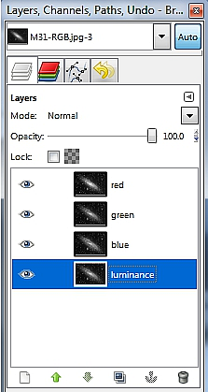

Take a look at the Layers dialogue box now. You should see four images. You want the luminance image on the bottom, so single-click on it, then click the down arrow in the dialogue box until it is at the bottom.

Right now, each image is grey but we want to make a color image.

- Change to color mode by going to Image → Mode → RGB.

- For each layer, change to Mode: Screen (in the layers box)

Now you want to choose a different color for each of your filtered images, using the same color as the filter.

HINT: Click the eye next to the layers you're not currently working on to make them invisible

- Click on the Red filter layer in the Layers dialogue box.
- In the image menu, go to Colors → Colorize.
- Use the slider to change the Hue (color) to Red
- Lower the Lightness (brightness) so that you don't see any white
- You may also with to play with the saturation
- Now, click on each of the remaining two layers (green and blue) and change those to their respective colors.

Now your job is to make a pretty picture. There's no hard and fast rule about how to do this. Here are some tips:

- The “knobs” you want to fiddle with are under the Colors menu:
Brightness and Contrast, as well as Hue and Saturation

- Make sure not to overwhelm one image with the other. You need the detail of the long unfiltered exposure, so make sure you can still see that.
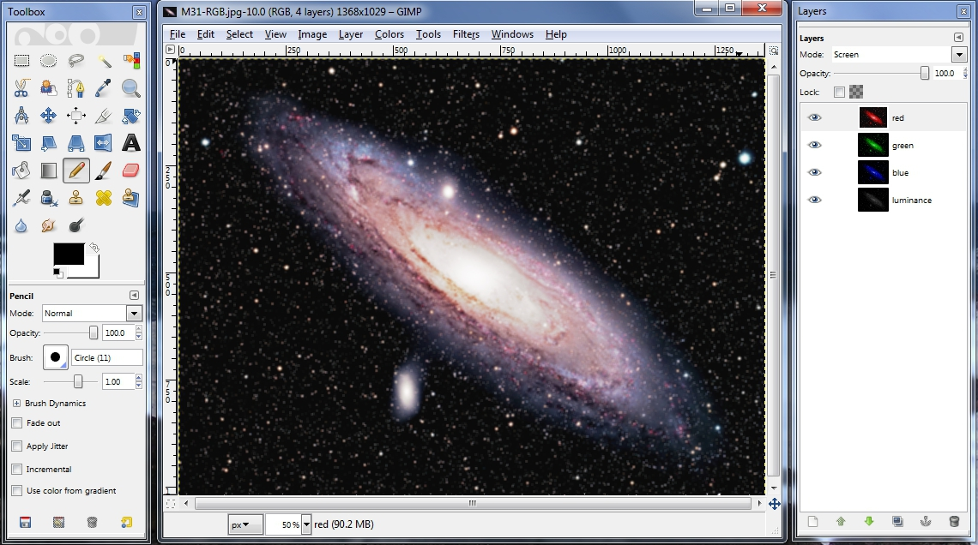
SAVE your image by going to File → Save As... Name it GroupX_Best.JPG, where X is your Group Number (remember to type the .JPG). When it asks you, click Export. A Quality of 85 is just fine.

Email the result to gtruch@stthomas.edu.

