The Age & Distance of a Star Cluster

Introduction - Relating color index to temperature.

Recall that we can use a spectrograph to measure the temperature of a dense object in space by locating the wavelength of the peak emission (λ_{max}) and applying Wein's Law. However, instead we used our telescope to take images through two filters, one centered in the blue (called B) and one centered in the green (called V). If we are using magnitudes, the color index is defined as the magnitude (brightness) of a star in the B filter minus its magnitude in the V filter.

Remember from last lab that we determined that B-V gives us the temperature by giving us the slope of the curve between those two filters. Thus a larger negative number gives a hotter star than a smaller negative number, and a larger positive number gives a cooler star than a smaller positive number (see Figure 1). We can get temperature straight from the B-V color index. This temperature will help us find both age of the cluster and the distance to it.

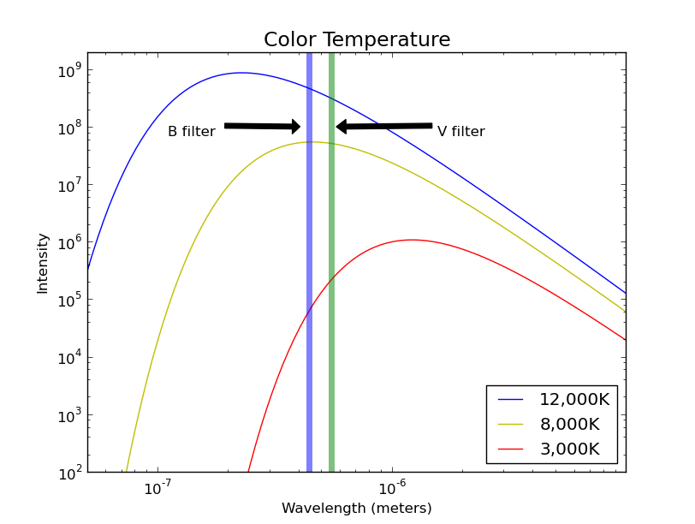Figure 1: Blackbody curves for objects at three different temperatures. Vertical stripes represent the wavelengths of the B and V filters.

Part 1 – Estimating the main sequence lifetime of a star

Stars generate energy through nuclear fusion, which converts mass directly into energy. The Luminosity of a star is essentially the rate at which that energy is produced. The higher the luminosity, the greater the rate of energy production. It turns out that the more massive a star is, the higher its luminosity, as shown in Table 1 below.

So the ratio of a star's Mass to its Luminosity is a good indicator of its relative main sequence lifetime as shown below where t_{ms} is the main sequence lifetime, M Is the stellar mass, L is the stellar luminosity, and K is an unknown constant:

Answer Part 1, Questions 1 and 2 in your answer packet

Table 1 – Spectral type versus color index, mass, and luminosity
Spectral Type | B-V | Mass  (M_{sun}) | Luminosity  (L_{sun})
B0 | -0.30 | 18 | 5x10⁵
B5 | -0.16 | 6.5 | 800
A0 | -0.01 | 3.2 | 80
A5 | 0.15 | 2.1 | 20
F0 | 0.32 | 1.7 | 6.0
F5 | 0.45 | 1.3 | 2.5
G0 | 0.60 | 1.1 | 1.26
G2 | 0.63 | 1.0 | 1.0
G5 | 0.68 | 0.93 | 0.79
K0 | 0.81 | 0.78 | 0.40
K5 | 1.15 | .69 | 0.16
M0 | 1.37 | .47 | 0.063
M4 | 1.52 | .21 | 0.0079
Part 2 – Estimating the age of a cluster

Stars rarely form in isolation. Generally, large clusters of stars form out of a single cloud of gas in a relatively short period of time. This means that all of the stars in a cluster are located in a small region of space and have approximately the same age. By creating an HR-Diagram of a cluster, we can visualize which stars in the cluster are still on the main sequence and which have evolved away.

The Main Sequence Turnoff for a cluster is the color index where stars begin deviating from the main sequence. In Figure 2 below, the main sequence turnoff for the Pleiades is at B-V=0.0, while that for M67 is at B-V=0.5.

Answer Part 2, Questions 1 and 2 in your answer packet.

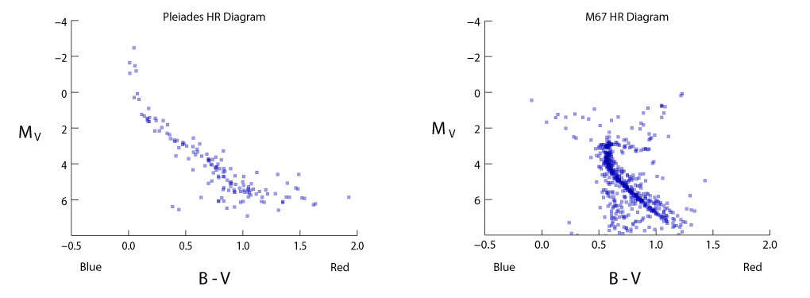Figure 2: HR Diagrams of two star clusters with different ages.

Go to the following URL:

http://ida.phys.stthomas.edu/gtr/HR_Diagram

You will create an HR Diagram for the star cluster that you find there.

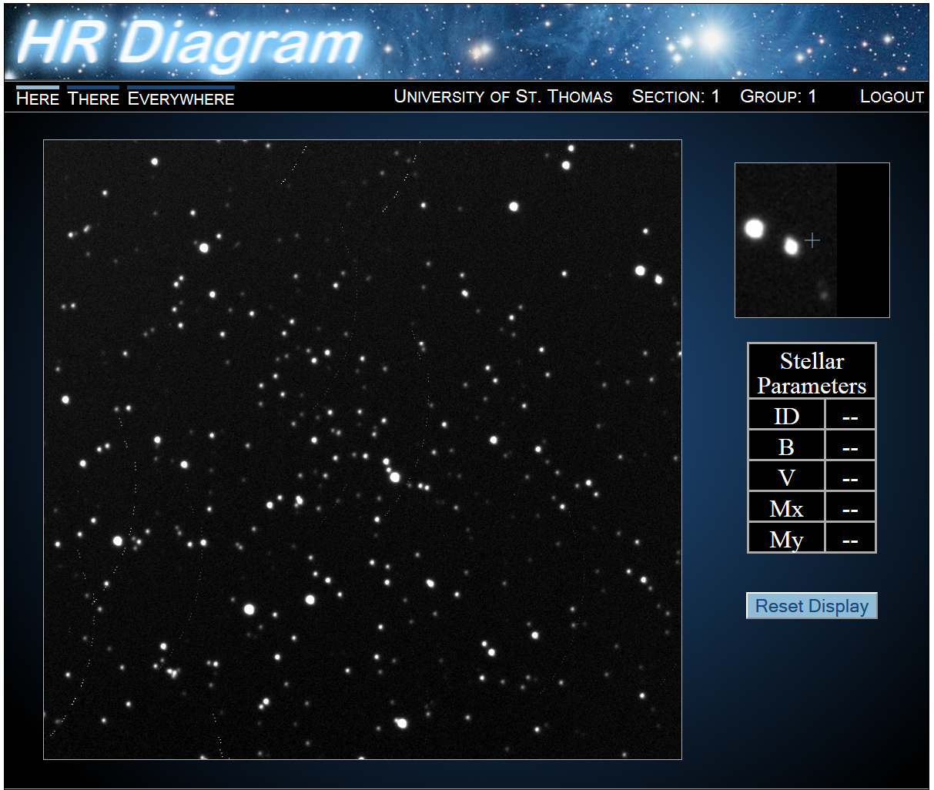
The screen of the website will look like this:
Figure 3: Star cluster data loaded into the image analysis tool. Notice the box at the upper right gives you a “close up” of where your mouse is.

Start by clicking on a star. Its information will appear in the table on the right. Stars you have already done will have a red circle around them. Enter this data (ID, B and V) into the excel spreadsheet.

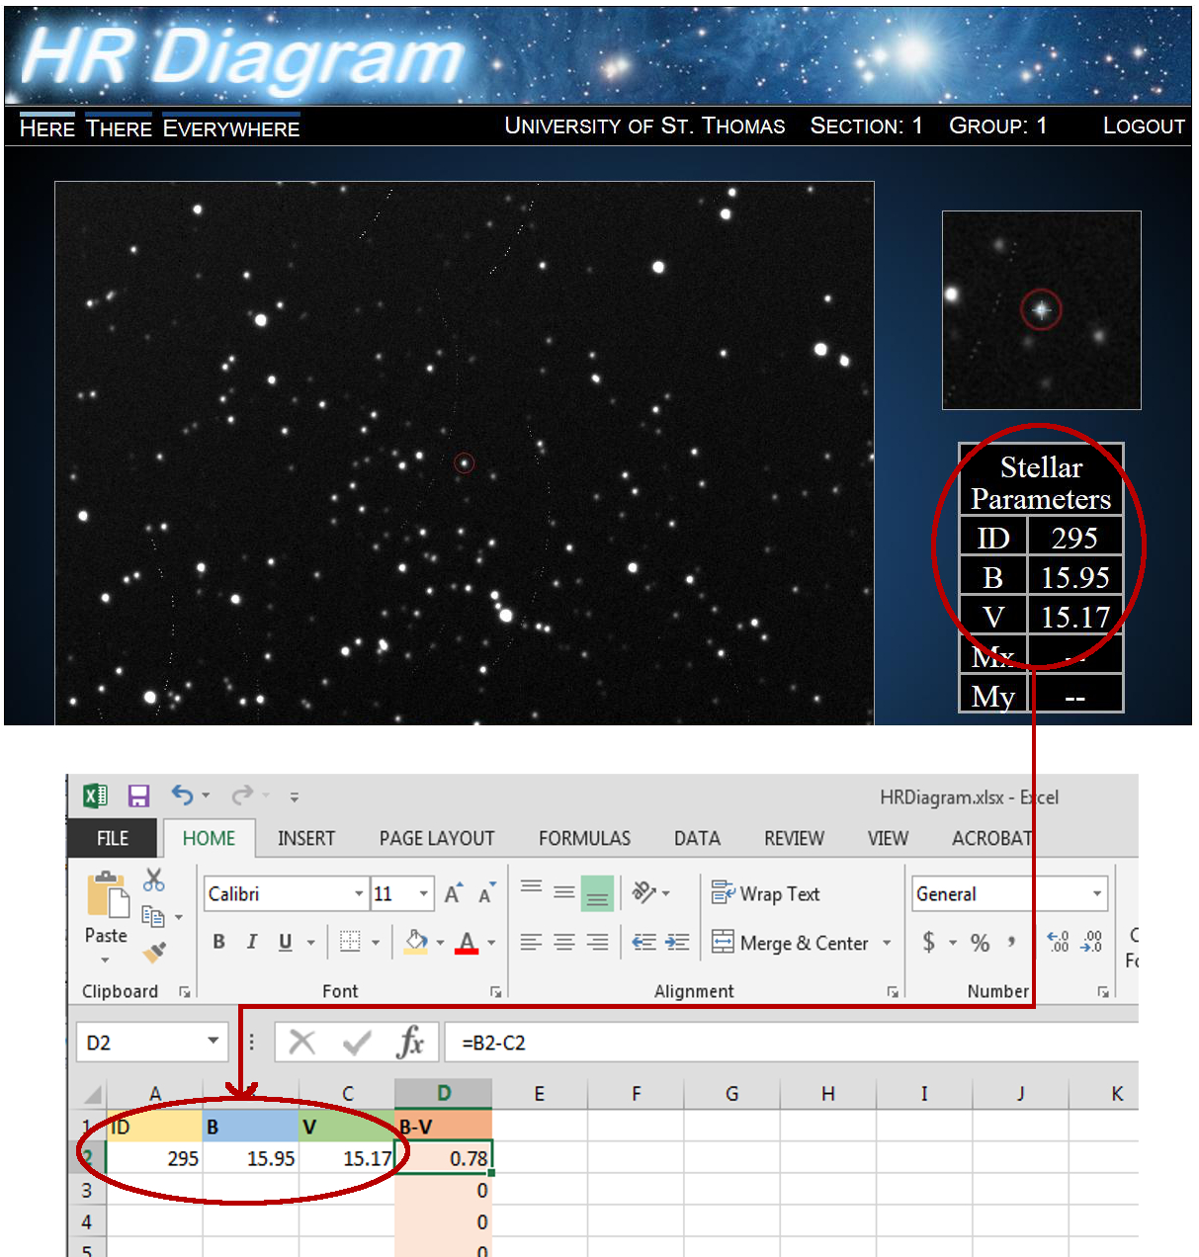

You will need to find data for about 100 stars in order to have enough to find the main-sequence turnoff. Begin in the center of the image and work outward, to reduce the number of foreground or background stars that are not part of the actual cluster.

The Excel spreadsheet will generate an H-R diagram from the data you've entered. Once you have entered enough data, select the “HR Diagram” tab at the bottom of the spreadsheet and email your HR Diagram to your instructor.

Finally, answer Part 2, Question 3 in your answer packet.
Part 3 – Distance
Use a couple of stars on your graph to estimate the distance. Choose stars that seem to be in the center (vertically) of the Main Sequence at different temperatures. The stars must be on the Main Sequence to use them for the distance! Below you will find temperatures for various Spectral Classes:

Spectral Type | B-V | Temperature  (K)
B0 | -0.30 | 29,200
B5 | -0.16 | 15,200
A0 | -0.01 | 9,600
A5 | 0.15 | 8,310
F0 | 0.32 | 7,350
F5 | 0.45 | 6,700
G0 | 0.60 | 6,050
G2 | 0.63 | 5,800
G5 | 0.68 | 5,660
K0 | 0.81 | 5,240
K5 | 1.15 | 4,400
M0 | 1.37 | 3,750
M4 | 1.52 | 3,400

Remember the spectral classes go from left to right, from 0 to 9 within each letter, and the letters go OBAFGKM. So B9 is just to the left of A0.

Enter the star’s V magnitude and B-V in Table 2. Then use the above table to determine the Temperature for four of your chosen stars, and enter that into Table 2.

Click on the link to the Theoretical HR Diagram at the top of the website.
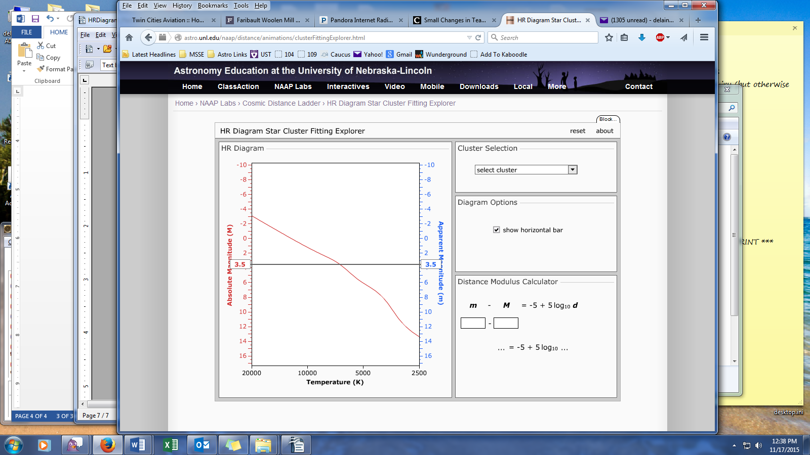
Check the box “Show Horizontal Bar”
You can grab and move the horizontal bar by clicking on the blue number of the Apparent Magnitude.
For each temperature of your stars, drag the bar up and down so that it crosses line of the Main Sequence at that temperature. Then read off the Absolute Magnitude this corresponds to. Enter the Absolute Magnitude in Table 2.

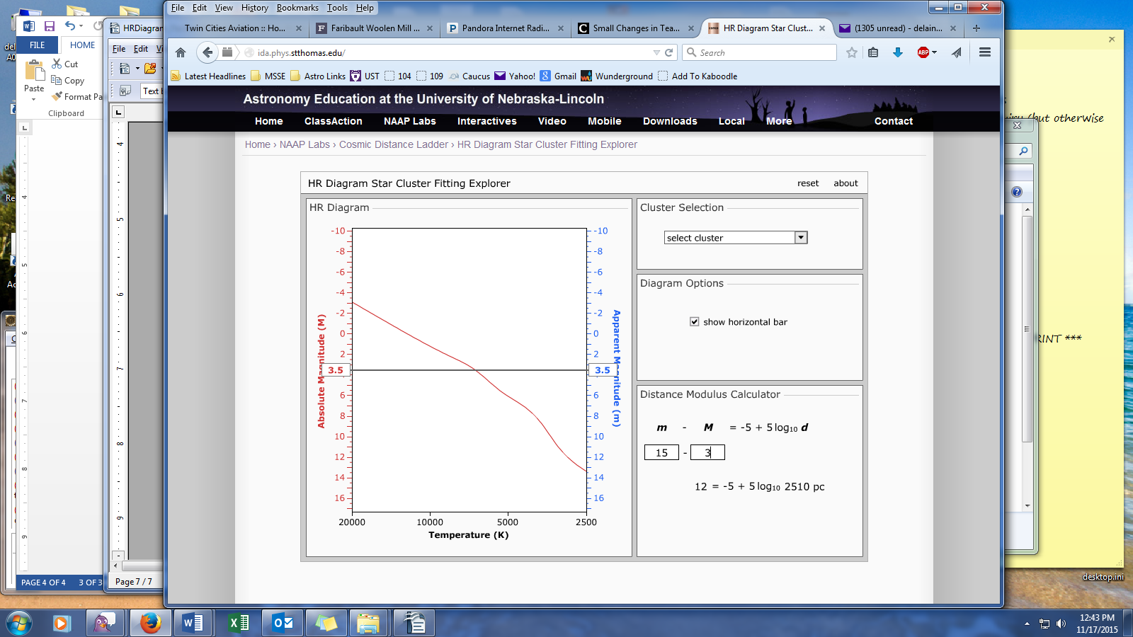
You now have both apparent magnitude and absolute magnitude. To calculate the distance, you can use the distance calculator on the above website. Enter the apparent magnitude in the “m” spot and the absolute magnitude in the “M” spot. The distance is calculated for you, and is found in the log10 (distance). Write down the distances in parsecs (this is just the number, not the log10) and find the average of your four distances.

Answer the remaining questions in the packet.
Distance here

