Estimating The Age of a Star Cluster

Part 1: - Relating color index to temperature.

We can use a spectrograph to measure the temperature of a dense object in space by locating the wavelength of the peak emission (λ_{max}) and applying Wein's Law. However, we are going to use our telescope to take images through two filters, one centered in the blue (called B) and one centered in the green (called V). The color index is defined as the magnitude (brightness) of a star in the B filter minus its magnitude in the V filter.

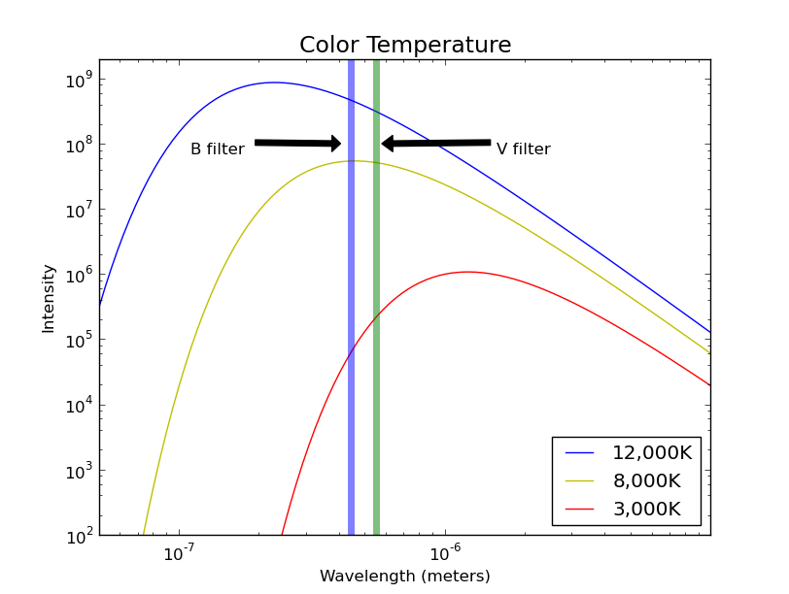Figure 1: Blackbody curves for objects at three different temperatures. Vertical stripes represent the wavelenghts of the B and V filters.

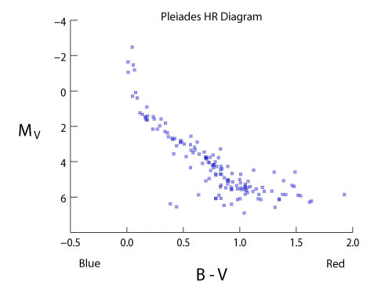
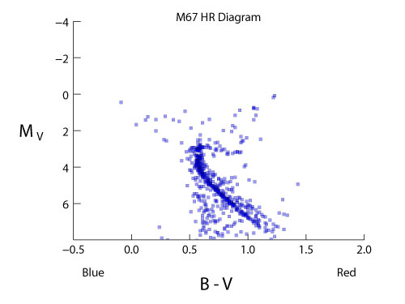

Table 1 – Spectral type versus color index, mass, and luminosity
Spectral Type | B-V | Mass  (M_{sun}) | Luminosity  (L_{sun})
B0 | -0.30 | 18 | 5x10⁵
B5 | -0.16 | 6.5 | 800
A0 | -0.01 | 3.2 | 80
A5 | 0.15 | 2.1 | 20
F0 | 0.32 | 1.7 | 6.0
F5 | 0.45 | 1.3 | 2.5
G0 | 0.60 | 1.1 | 1.26
G2 | 0.63 | 1.0 | 1.0
G5 | 0.68 | 0.93 | 0.79
K0 | 0.81 | 0.78 | 0.40
K5 | 1.15 | .69 | 0.16
M0 | 1.37 | .47 | 0.063
M4 | 1.52 | .21 | 0.0079

