The Age of a Star Cluster

Part 1: - Relating color index to temperature.

We can use a spectrograph to measure the temperature of a dense object in space by locating the wavelength of the peak emission (λ_{max}) and applying Wein's Law. However, we are going to use our telescope to take images through two filters, one centered in the blue (called B) and one centered in the green (called V). The color index is defined as the magnitude (brightness) of a star in the B filter minus its magnitude in the V filter.

Answer Part 2, Questions 1 through 3 in your answer packet keeping in mind that a high magnitude indicates a dim star and that a low magnitude indicates a bright star. The y-axis of the plot below shows intensity, which increases with brightness.

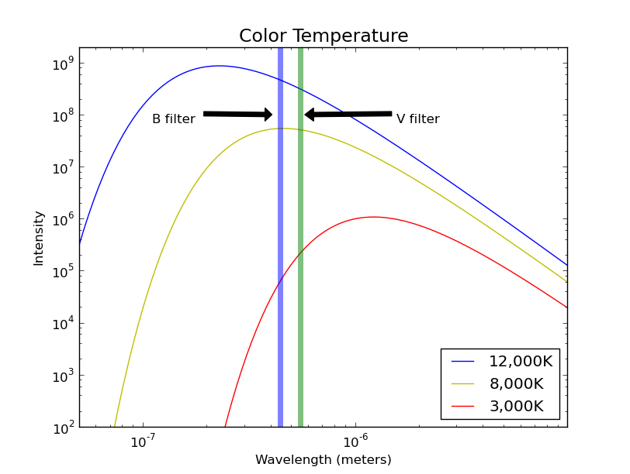Figure 1: Blackbody curves for objects at three different temperatures. Vertical stripes represent the wavelengths of the B and V filters.

Part 2 – Estimating the main sequence lifetime of a star

Stars generate energy through nuclear fusion, which converts mass directly into energy. The Luminosity of a star is essentially the rate at which that energy is produced. The higher the luminosity, the greater the rate of energy production. It turns out that the more massive a star is, the higher its luminosity, as shown in Table 1 below.

So the ratio of a star's Mass to its Luminosity is a good indicator of its relative main sequence lifetime as shown below where T_{ms} is the main sequence lifetime, M Is the stellar mass, L is the stellar luminosity, and K is an unknown constant:

Answer Part 2, Questions 1 and 2 in your answer packet

Table 1 – Spectral type versus color index, mass, and luminosity
Spectral Type | B-V | Mass  (M_{sun}) | Luminosity  (L_{sun})
B0 | -0.30 | 18 | 5x10⁵
B5 | -0.16 | 6.5 | 800
A0 | -0.01 | 3.2 | 80
A5 | 0.15 | 2.1 | 20
F0 | 0.32 | 1.7 | 6.0
F5 | 0.45 | 1.3 | 2.5
G0 | 0.60 | 1.1 | 1.26
G2 | 0.63 | 1.0 | 1.0
G5 | 0.68 | 0.93 | 0.79
K0 | 0.81 | 0.78 | 0.40
K5 | 1.15 | .69 | 0.16
M0 | 1.37 | .47 | 0.063
M4 | 1.52 | .21 | 0.0079
Part 3 – Estimating the age of a cluster

Stars rarely form in isolation. Generally, large clusters of stars form out of a single cloud of gas in a relatively short period of time. This means that all of the stars in a cluster are located in a small region of space and have approximately the same age. By creating an HR-Diagram of a cluster, we can visualize which stars in the cluster are still on the main sequence and which have evolved away.

The Main Sequence Turnoff for a cluster is the color index where stars begin deviating from the main sequence. In Figure 2 below, the main sequence turnoff for the Pleiades is at B-V=0.0, while that for M67 is at B-V=0.5.

Answer Part 3, Questions 1 and 2 in your answer packet.

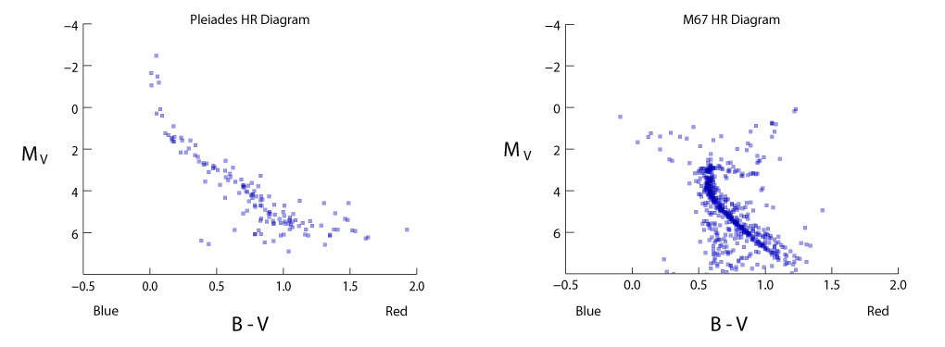Figure 2: HR Diagrams of two star clusters with different ages.

Go to the following URL:

http://ida.phys.stthomas.edu/gtr/HR_Diagram

You will create an HR Diagram for the star cluster that you find there.

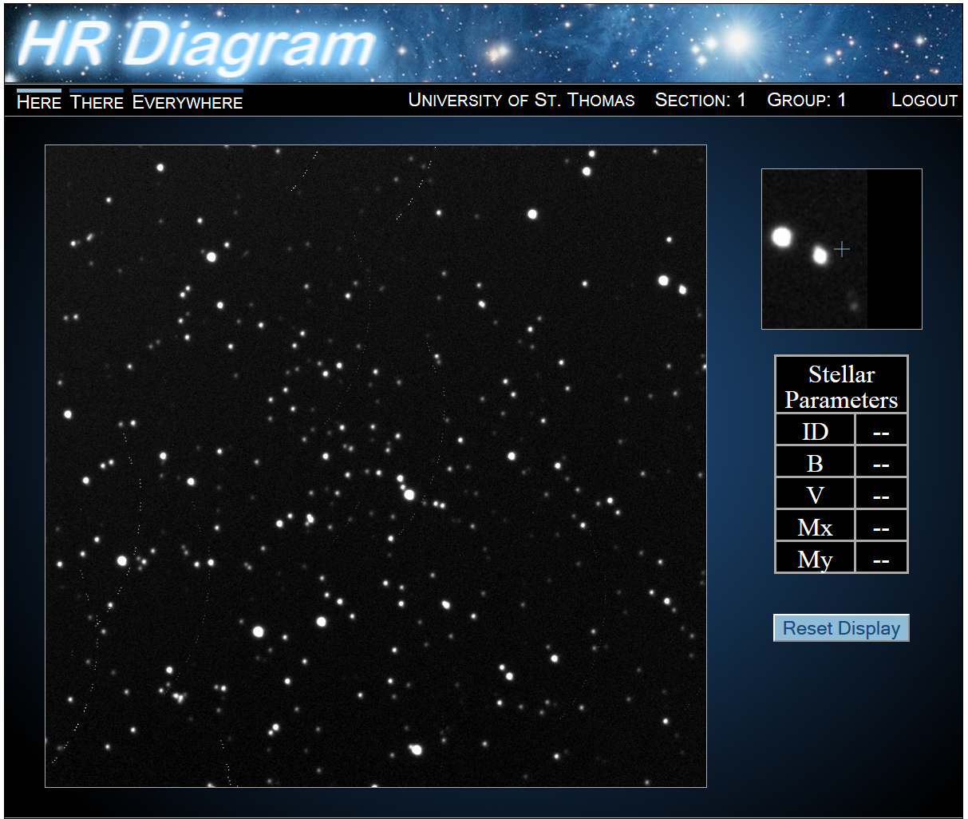
The screen of the website will look like this:
Figure 3: Star cluster data loaded into the image analysis tool. Notice the box at the upper right gives you a “close up” of where your mouse is.

Start by clicking on a star. Its information will appear in the table on the right. Stars you have already done will have a red circle around them. Enter this data (ID, B and V) into the excel spreadsheet.

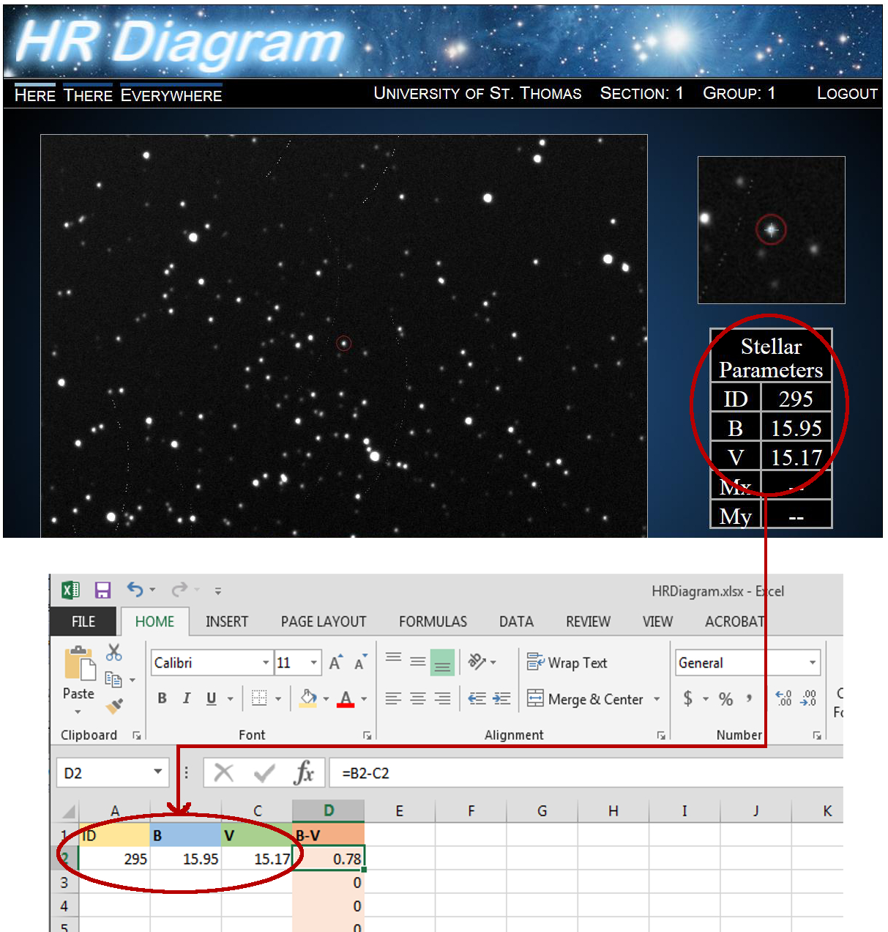

You will need to find data for about 100 stars in order to have enough to find the main-sequence turnoff. Begin in the center of the image and work outward, to reduce the number of foreground or background stars that are not part of the actual cluster.

The Excel spreadsheet will generate an H-R diagram from the data you've entered. Once you have entered enough data, select the “HR Diagram” tab at the bottom of the spreadsheet and email your HR Diagram to your instructor.

Finally, answer Part 3, Question 3 in your answer packet.

