Impacts from Space

Turn in one copy of this lab with each group member's printed name and signature. By signing, you certify that you have actively participated in the exercise and have put forth effort in equal share to your fellow group members.

Printed Name Signature

______________________ _____________________

______________________ _____________________

______________________ _____________________

______________________ _____________________

Data Tables

Table 1- Ball bearing masses
Ball Bearing | Mass
#1
#2
#3

Table 2- Trials for Ball Bearing #1
Trial Number | Height  (cm) | Crater Diameter  (cm) | Energy  (ergs)
1
2
3

Table 3- Trials for Ball Bearing #2
Trial Number | Height  (cm) | Crater Diameter  (cm) | Energy  (ergs)
1
2
3

Table 4- Trials for Ball Bearing #3
Trial Number | Height  (cm) | Crater Diameter  (cm) | Energy  (ergs)
1
2
3
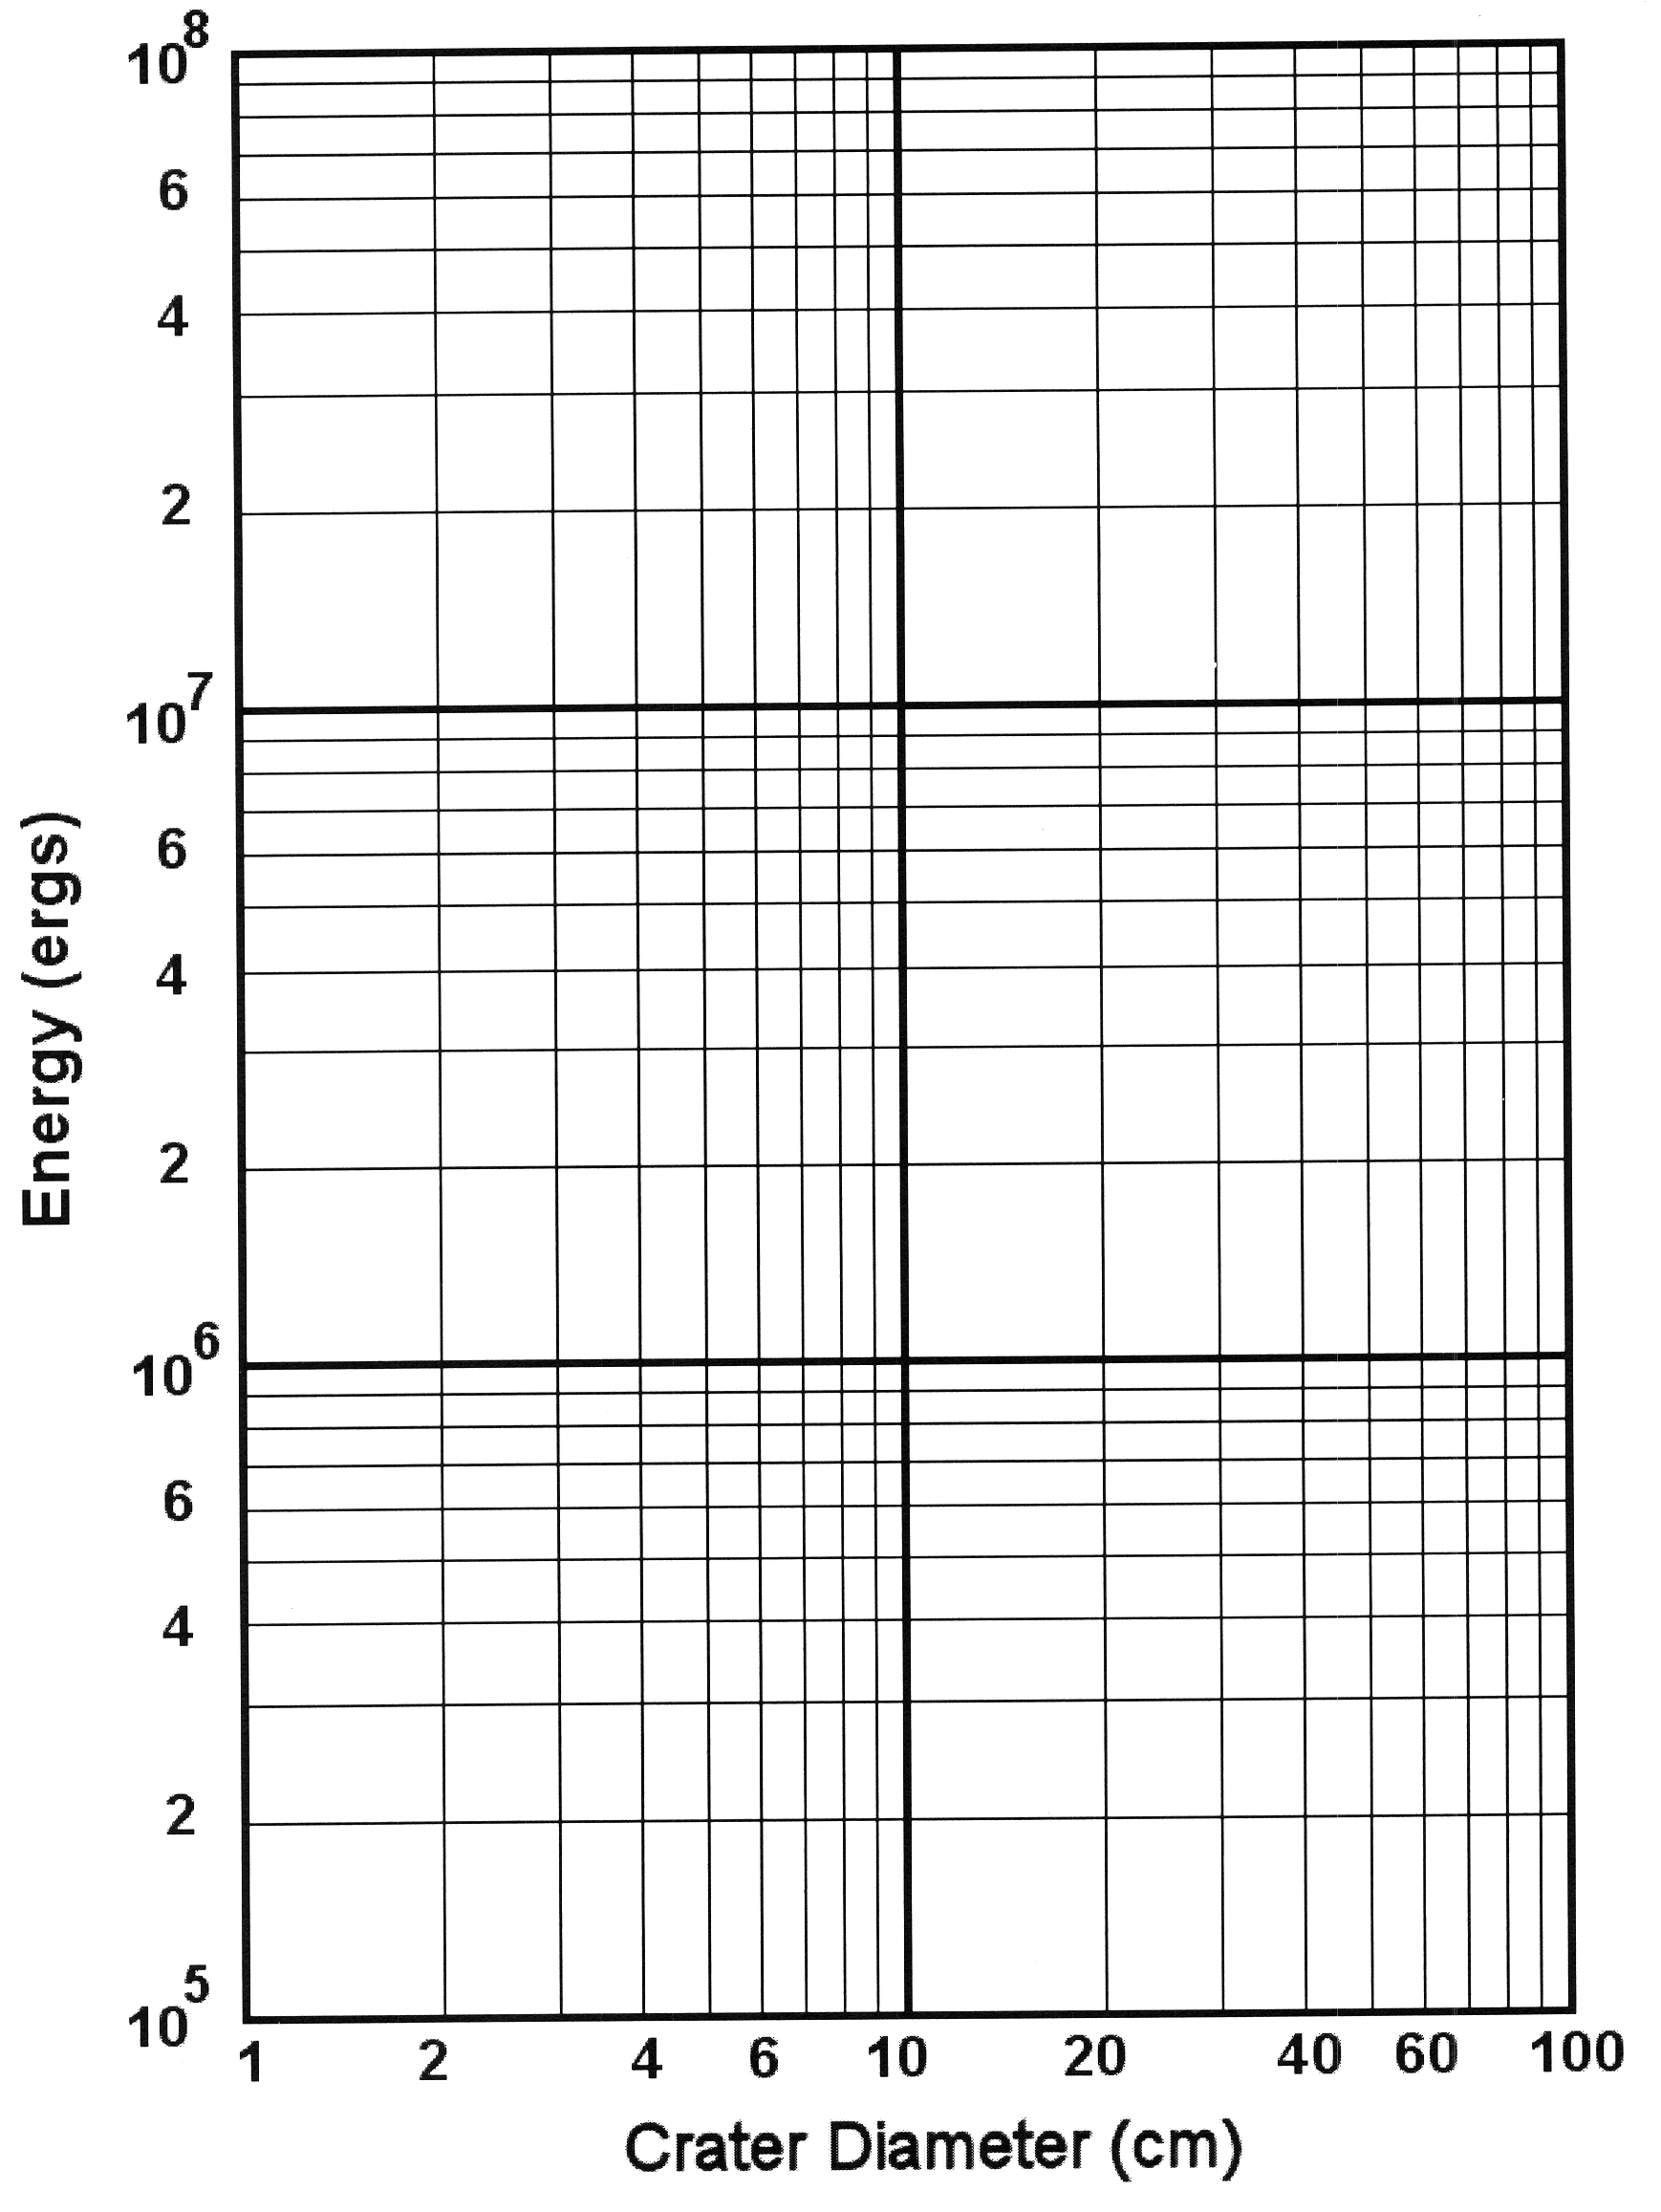
Graph 1

Crater diameter when Energy = 1x10⁵ ergs: ______________

Crater diameter when Energy = 1x10⁸ ergs: ______________
Graph 2
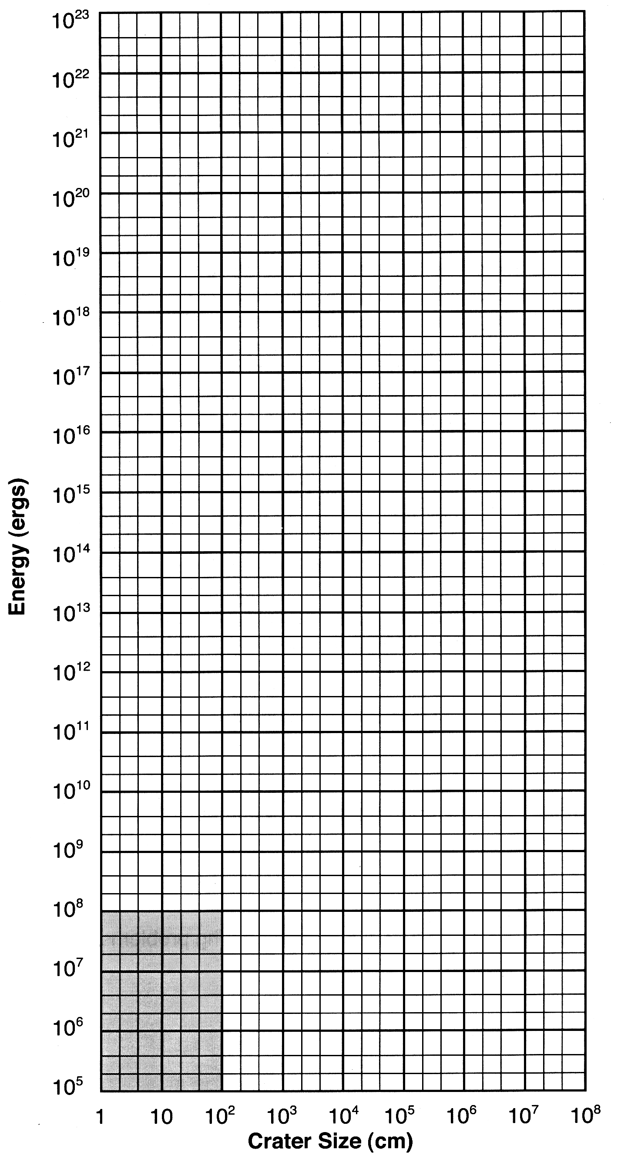
Questions

- Does the correlation that you observed on Graph 1 make physical sense? Explain.

- Are there any points that are not on the line? If so, can you think of a reason why?

- PREDICT the energy of the largest ball bearing when dropped from two meters. Use your best fit line on Graph 1 to estimate the crater size.
SHOW YOUR WORK!

- Drop the large ball bearing from two meters. Did your prediction in question 3 work? How far off was it? What are the possible sources of error? Don't just say "Human Error." Think about the precision of your measurements and how you're performing the experiment.

In the next few questions, we'll try to estimate the size of the meteor that created Meteor Crater in Arizona.

- Meteor Crater is approximately 1.4 km across. Using your line on Graph 2, estimate the energy needed to create such a crater. Record your answer here.

- Geologists estimate that about 1x10²³ ergs of energy were required to create the impact. Do you get the same answer?

- Before you drop your ball bearing, it has potential energy, which converts to kinetic energy by the time of the impact. What happens to that kinetic energy when the meteor hits the ground?

- Your answer in number 1 is probably low. Apart from errors mentioned above, why does this experiment tend to underestimate the energy? Think about where the kinetic energy of the impact is going in the sandbox versus in a large impact with the Earth.

- Let's assume that the meteoroid was going at normal orbital speeds. Calculate the orbital speed of the Earth in cm/s. (1 A.U. = 93 million miles =1.5x10⁸ km) SHOW YOUR WORK!

- Using your calculated orbital speed and the equation for kinetic energy, estimate the mass of the impactor. The kinetic energy of an object in motion is expressed as:

where m is the mass in grams and v is the velocity in centimeters per second. SHOW YOUR WORK!

