Revolution of Jupiter's Moons
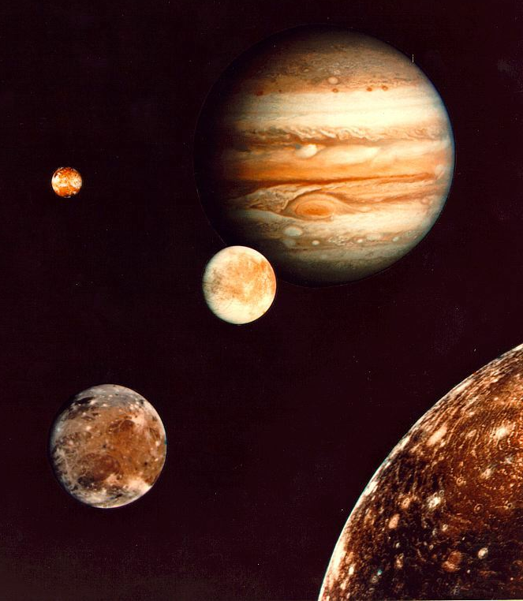
Introduction

In 1543 Copernicus hypothesized that the planets revolve in circular orbits around the sun. Not much later, Tycho Brahe carefully observed the location of the planets over a period of 20 years using a sextant and compass. These observations were used by his student, Johannes Kepler, to deduce three empirical mathematical laws governing the orbit of one body around another.

His first law is that the planets orbit the sun as ellipses, rather than circles. This solved the “horribly complex” issue with the Ptolemeic model of the solar system, with its epicycles, although it wasn't until more accurate data was available that it could be tested more thoroughly.

His second law was that a planet travels its orbit with equal areas in equal times. In other words, when a planet is closest to the sun, it moves fastest, and when it's farthest it moves slowest. For planets, which move nearly on circles, this isn't a big difference. For comets, it can be!

Kepler's third law notes that you can measure the mass of the sun by measuring the period and semi-major axis of a planet orbiting the sun.

In 1609 the telescope was invented. When Galileo turned his telescope to the skies the next year, he could see Jupiter's four largest moons. His observations of their orbit was part of his argument that the Earth orbited the Sun, rather than the other way around: since he could see things orbiting Jupiter, he argued, it only made sense that it was a possibility for the Earth to orbit the Sun. Unfortunately for Galileo, the Inquisition took issue with his findings; he was tried and forced to recant and spent the rest of his life under house arrest.

Today we'll follow in the footsteps of Galileo in making observations of the four brightest moons of Jupiter. Since they behave like a miniature solar system, we can then use Kepler's 3rd Law to calculate Jupiter's mass. Fortunately for us, the Pope apologized to Galileo about the whole Inquisition thing (400 years after Galileo's death), so we won't have to worry about that.
Part 1: Conceptual View

Step 1: Setting up the Telescope
- Click on the CLEA folder on the desktop
- Start the program Jupiter's Moons
- Log in, using initials for each group member and your group number
- Go to File → Run
- A dialogue box will open:
  - Check that Calendar is checked under Date/Time Format
  - Check that the date is correct and that the time is 00:00:00
  - Click OK

The screen will show Jupiter in the center, along with several (usually three or four) of its moons.

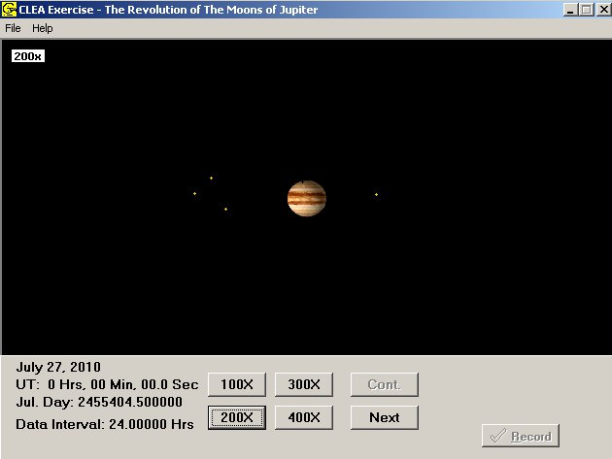

If you were taking pictures, all you would get at one time would be exactly what you see here – a static image. But, since this is a simulation, we can take a quick look at how things move over time.

- Go to File → Features and and check the box next to Animation
- Click OK to return to the main window
- Click on the Cont. button

You should be able to see the moons moving around Jupiter now. Watch the motion a little to get a sense of how the moons appear to move.

- Answer questions 1-3 in the packet based on what you observe.
- Click on the Cont. button again to stop the motion
- Go to File → Features and and uncheck the box next to Animation
- Go to File → Timing... and change Observation Step to 12 hours

Part 2: Taking Data

You will now begin taking data. In this simulation, clicking on one of the moons will give you information about it, such as its name and how far from Jupiter it is.

- Click and hold on the image to get a cross-hairs
- Center the cross-hairs on one of the moons, then release
- Click the Record button. A window will pop up, just move it out of the way
- Repeat 1-3 for the other moons in the image
- When you are done, click Next for the next observation. NOTE: the little window will disappear. That is OK. As long as you hit “record” your data will still be there.
- Repeat until you have made 20 sets of observations (This will be more than 10 days, since some nights it will be cloudy.)
- View your data by going to File → Data → Review/Edit/Print
- Print your data sheet by going to List → Print → OWS 166. Be sure to attach it to the answer sheet!
Part 3: Graphing

We want to find the period and radius of each moon's orbit. To do this, we need to plot the data on a graph and fit a curve to it. We'll plot our observational data – distance from Jupiter vs. time – on a separate graph for each moon.

- Start with Callisto. Make a graph with “distance” on the y-axis and “time” on the x-axis.
- Plot the points for Callisto on your graph.
- Try to draw a smooth curve through the points (don't just connect point to point, as this will lead to a jagged line). Hint: It may help to put a dashed line along the maximum distance from Jupiter.
- Label your graph with the moon's name.
- Repeat steps 1-4 for Ganymede (remember to make a separate graph for each moon), Europa, and Io.
- Answer questions 4 and 5.

Be sure to attach your graphs to the answer packet before you leave.

Part 4: Analysis

We're now ready to measure the mass of Jupiter! To do this we are going to use Kepler's 3rd Law:

M = a³ / P²

M is the mass of the central object (in this case, Jupiter)
a is the semi-major axis (which is the radius, if the orbit is a circle)
P is the period (the time it takes to go around once)

Let's find a and P for each of our moons.

- Measure the maximum distance from Jupiter for each moon. Write this number in column 2 of Table 1. Use your curve not a data point!!
- Measure the period by measuring one wavelength. Write this in column 3 of Table 1.

Now, these numbers are in the less-than-useful “Jupiter Diameter” (for distance) and “Days” (for time). To calculate the mass of Jupiter, it's more useful to use the special units of “A.U.” and “years”.

- Convert your numbers for a to astronomical units by dividing by 1050 (this may seem arbitrary, but it is the number of Jupiters that can fit in one A.U.)
- Convert your days to years.
- Write your new numbers in columns 4 and 5 of Table 1

Now, we can calculate the mass of Jupiter! Let's see how well the different moons match up.

- Calculate the mass of Jupiter four times, once for each moon. Use Kepler's 3rd Law, M = a³ / P² and write your answers in Table 3
- Calculate the average and write that in Table 2
- Answer the remaining questions in the answer packet.

