**Revolution of Jupiter's Moons**

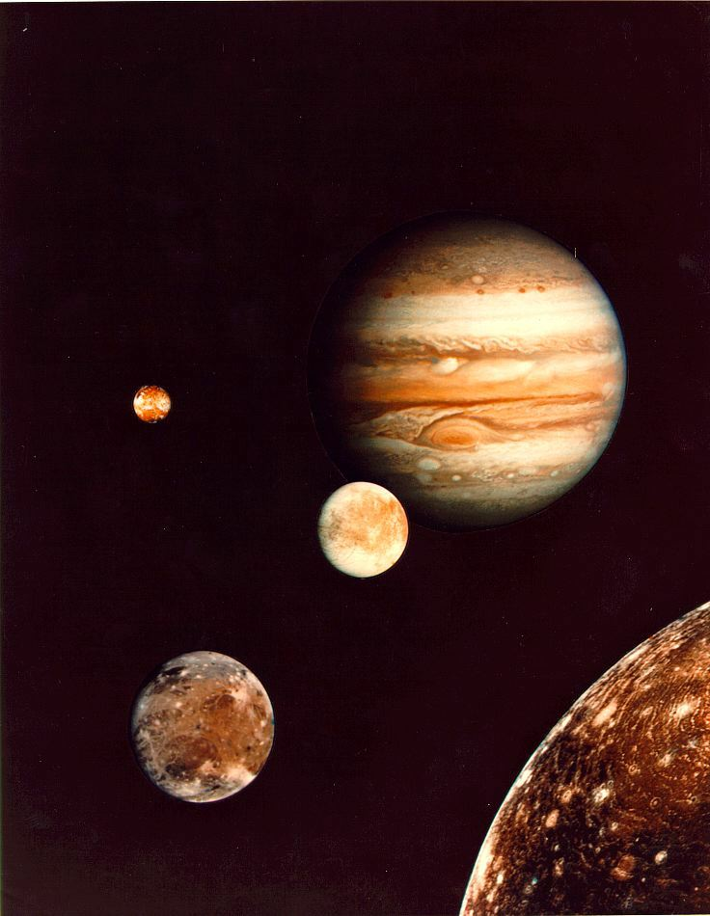

**Introduction**

In 1543 Copernicus hypothesized that the planets revolve in circular orbits around the Sun. Not much later, Tycho Brahe carefully observed the location of the planets over a period of 20 years using a sextant and compass. These observations were used by his student, Johannes Kepler, to deduce three empirical mathematical laws governing the orbit of one body around another.

His first law is that the planets orbit the sun as ellipses, rather than circles. This solved the “horribly complex” issue with the Ptolemeic model of the solar system, with its epicycles, although it wasn't until more accurate data was available that it could be tested more thoroughly.

His second law was that a planet travels its orbit with equal areas in equal times. In other words, when a planet is closest to the sun, it moves fastest, and when it's farthest it moves slowest. For planets, which move nearly on circles, this isn't a big difference. For comets, it can be!

Kepler's third law notes that you can measure the mass of the sun by measuring the period and semi-major axis of a planet orbiting the sun.

In 1609 the telescope was invented. When Galileo turned his telescope to the skies the next year, he could see Jupiter's four largest moons. His observations of their orbit was part of his argument that the Earth orbited the Sun, rather than the other way around: since he could see things orbiting Jupiter, he argued, it only made sense that it was a possibility for the Earth to orbit the Sun. Unfortunately for Galileo, the Inquisition took issue with his findings; he was tried and forced to recant and spent the rest of his life under house arrest.

Today we'll follow in the footsteps of Galileo in making observations of the four brightest moons of Jupiter. Since they behave like a miniature solar system, we can then use Kepler's 3rd Law to calculate Jupiter's mass. Fortunately for us, the Pope apologized to Galileo about the whole Inquisition thing (400 years after Galileo's death), so we won't have to worry about that.

**Part 1 – Kepler's Third Law**

In this section, we will develop an understanding of Kepler's Third Law by exploring several relationships:

Investigate the relationship between ***orbital period*** and ***orbital velocity***.

* In your group, answer **Part 1, Questions 1, 2, and 3** in your answer packet.
* Compare answers with your partner group to come to a consensus.
* Report your results to the class.

Kepler's Third Law is $a^{3}={kP}^{2}$, where *a* is the semi-major axis and *P* is the period and *k* is a constant. Assuming circular orbits, investigate what happens to the ***orbital velocity*** and ***orbital period*** of a planet when the ***orbital radius*** is increased.

* In your group, answer **Part 1, Questions 4 and 5** in your answer packet.
* Report your answers to the class.
* Open the orbit simulation on the computer (your instructor will tell you how). Enter the starting values from the table below. Using the ruler tool, verify that the orbit is circular. *You may have to adjust the velocity*.

|  |  |  |  |  |  |
| --- | --- | --- | --- | --- | --- |
|  | Mass | X-Pos. | Y-Pos | X-Vel. | Y-Vel. |
| Body 1 | 1000 | 0 | 0 | 0 | 0 |
| Body 2 | 1 | 142 | 0 | 0 | 265 |

* Answer **Part 1, Question 6** in the answer packet. Share your result with the class.
* Test your prediction with the simulator.

Once Newton came up with his ideas about gravity, he was able to tie them to Kepler’s laws. Using these ideas we have a generalized version of Kepler's Third Law, which shows that the constant *k* is related to both the central mass and the mass of the orbiting body:

$a^{3}=P^{2}\frac{G(M+m)}{4π^{2}}$,

Let’s see what happens to the ***orbital velocity*** and ***orbital period*** of a circular orbit if the central mass is increased:

* Reset the simulator to the starting values given in the previous table.
* Increase the mass of the orbiting body (body 2) until there is a noticeable wobble in the central mass.
* In your group, answer **Part 1, Questions 7 and 8.**
* Work with your partner group to come to a consensus on your answers.
* Share your answers with the class.

**Part 2:**

In this section, we look at the Jovian system.

* Below is a typical snapshot of Jupiter and its moons. Use the picture to answer **Part 2, Questions 1 and 2**.
* Compare your answer with your partner group and come to a consensus on the answer.

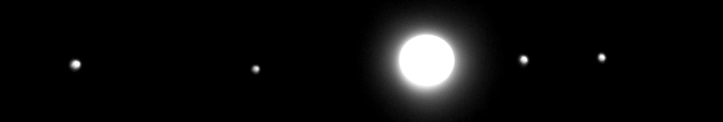

* Below are three snapshots of the of the Jovian system as viewed from above Jupiter's north pole. Sketch the system as it would be seen from Earth. Share your sketches with the class.

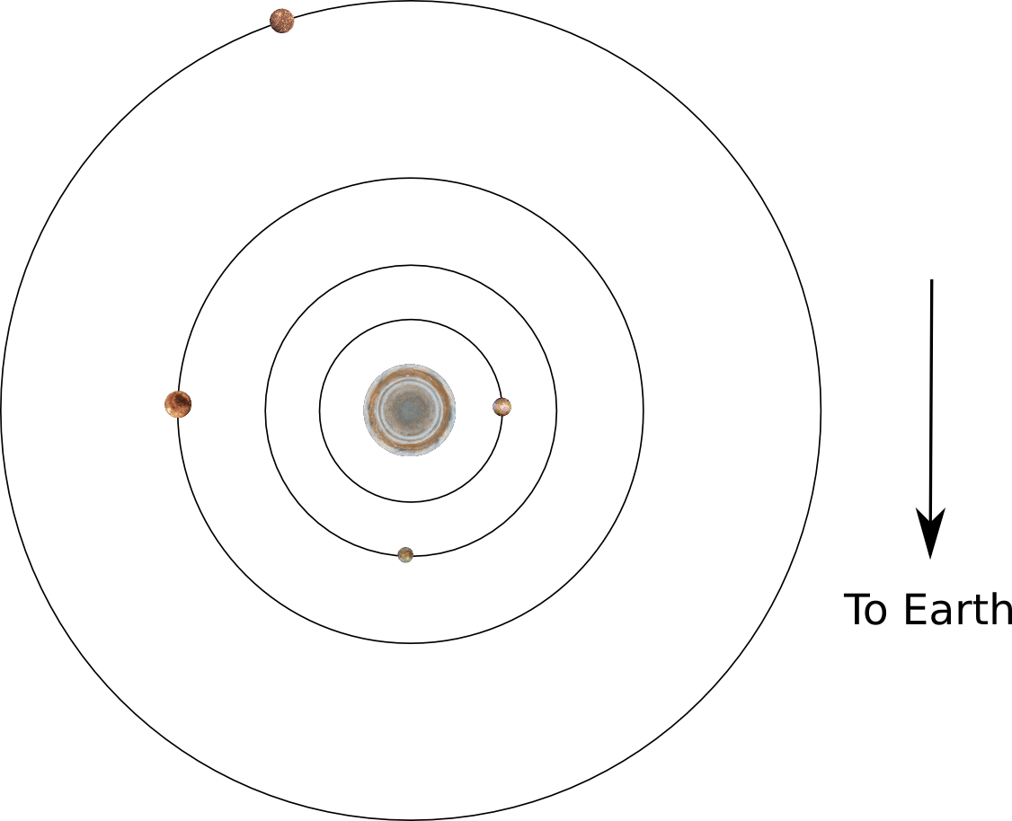Step 1

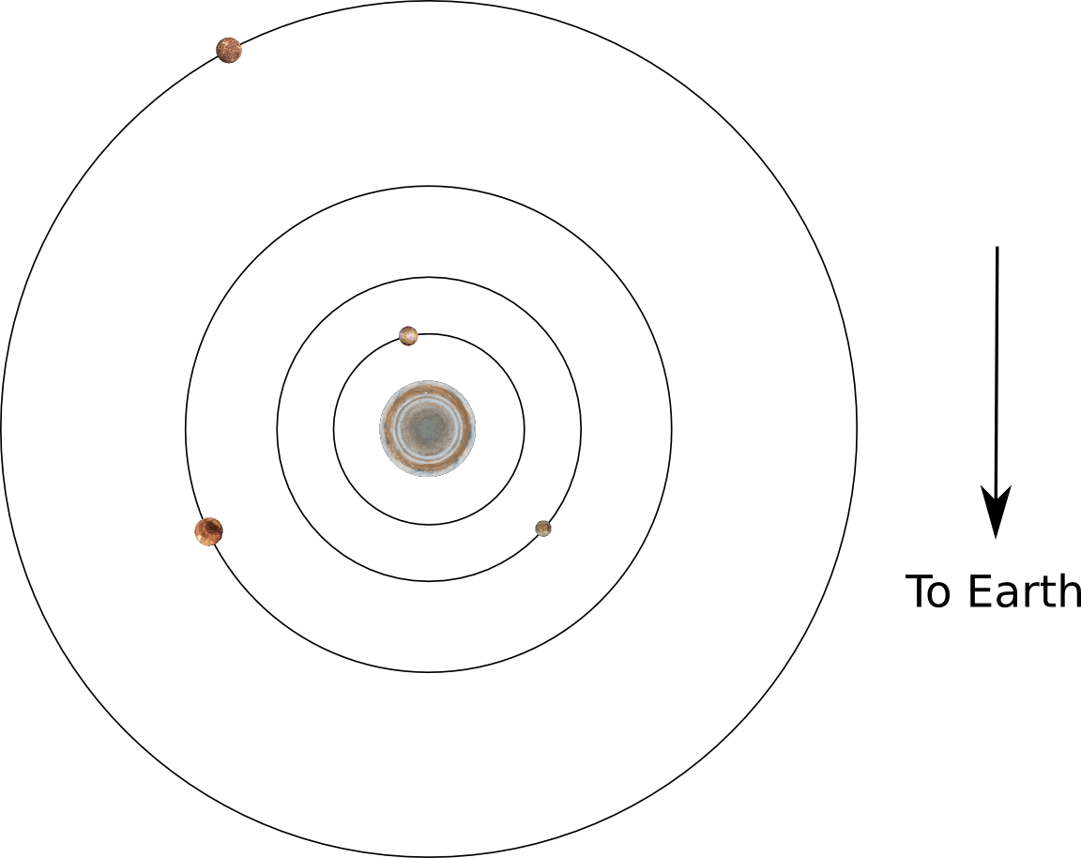Step 2

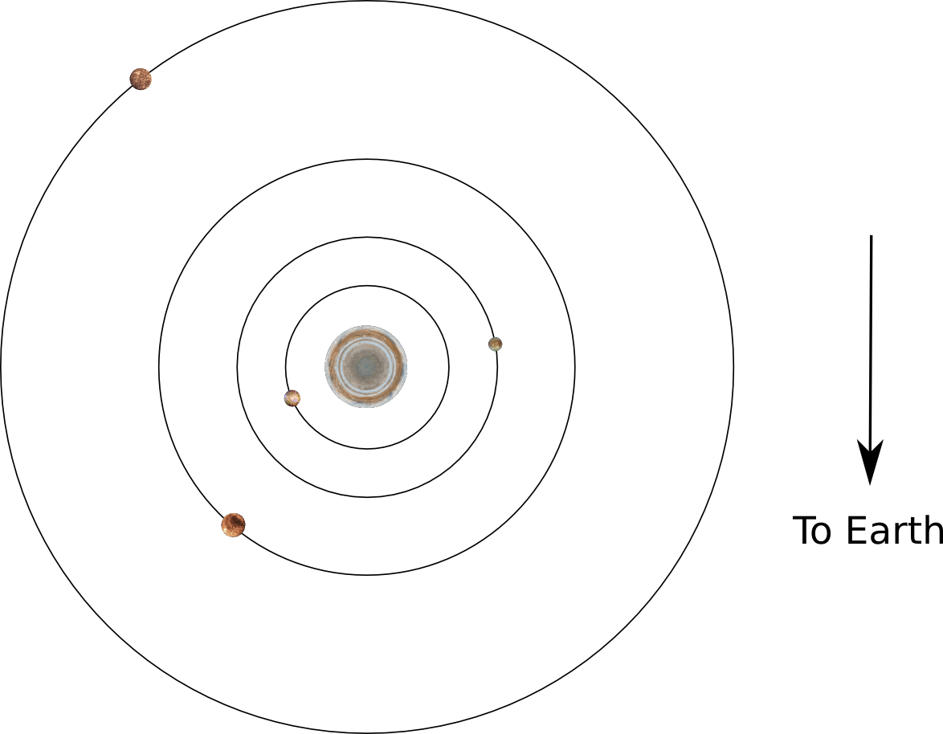Step 3

* The snapshots above were taken **12 hours apart** from each other. Use this information to answer **Part 2, Questions 4 and 5.**

**Part 3:**

In this section, we will determine how to “weigh” Jupiter using images of the Jovian system and develop an observing plan.

* In your groups, answer **Part 3, Questions 1 and 2**. Share your results with the class.
* Answer Question 3 as part of a class discussion.
* In your groups, determine a set of of observing parameters. Enter them in the table in Question 4. Discuss your parameters with the class. Log into the observation submission page and submit your observing request.