**Revolution of Jupiter's Moons**

Turn in one copy of this lab with each group member's printed name and signature. By signing, you certify that you have actively participated in the exercise and have put forth effort in equal share to your fellow group members.

**Printed Name Signature**

**______________________ _____________________**

**______________________ _____________________**

**______________________ _____________________**

**______________________ _____________________**

**Part 1**

Investigating the relationship between ***orbital period*** and ***orbital velocity***:

1. Develop a definition of ***orbital period***.

2. Develop a definition of ***orbital velocity***.

3. The planet Earth has an ***orbital period*** of 365.25 days. Assuming that the orbit is perfectly circular and that Earth is 92.956 million miles from the Sun, calculate the ***orbital velocity*** of the Earth in miles per hour.

Explore what happens to the ***orbital period*** and ***orbital velocity*** of a planet when the ***orbital radius*** is increased using your simulation. Compare with Kepler’s 3rd Law ($a^{3}={kP}^{2}$) to see if it makes sense.

4. In Kepler’s 3rd Law, what is the ***orbital radius*** if the orbit is a circle?

5. Using the equation, if the ***orbital radius*** increases, does the ***orbital period*** increase, decrease, or stay the same?

6. Using the simulation, double the initial ***orbital radius*** (X-Pos). Find the ***orbital velocity*** (Y-Vel) that you need for a circular orbit with radius twice the initial radius. Did the ***orbital velocity*** increase, decrease, or stay the same for the orbit to stay circular?

7. At what mass did you see wobble in the ***central mass***? The sun’s mass is 332,946 times the mass of Earth. Do you expect the Earth to cause significant “wobble” in the Sun?

8. Insert A Question Here re: why mass goes up -> higher velocity, why if radius goes up -> lower velocity leading to gravitational force being higher.

**Part 2**

1. Why do Jupiter's moons appear in a straight line in the image shown?

2. List everything that you could possibly measure in an image of Jupiter and its moons.

3. Sketch the view from Earth of each of the three Jovian system snapshots in Part 2.

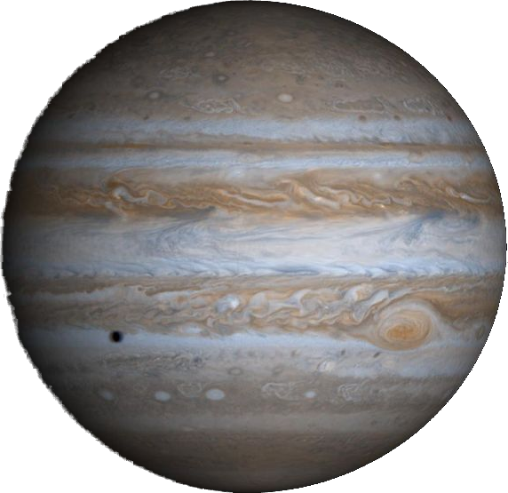

Step 1



Step 2



Step 3

4. Estimate the ***orbital period*** of each of the four Galilean moons.

Explain your process!

|  |  |
| --- | --- |
| **Moon** | **Orbital Period** |
| I |  |
| II |  |
| III |  |
| IV |  |

5. The orbits of Jupiter's moons are almost completely circular. Appealing to Kepler's Second Law, what does this imply about their orbital velocity?

6. We are viewing the system edge on. At what point in the orbit does the moon *appear* to move the fastest? The slowest? Why?

**Part 3**

1. Looking at the generalized version of Kepler's Third Law from Part 1, assume that the mass of any moon is small compared to the mass of Jupiter and that we know the gravitational constant G. What do we need to know to solve this equation for the mass of Jupiter?

2. Can we measure these values from a single image of Jupiter? If yes, how? If no, why not and what is the solution?

3. Given your answers to Part 2 Question 2 and Part 3 Question 2, describe the data that you expect to gather and sketch a plot of what you expect to see.

4. Record your observing parameters in the table below.

|  |  |
| --- | --- |
| Number of Images per Night |  |
| Time Between Images |  |
| Number of Nights to observe |  |