Measuring the Sky

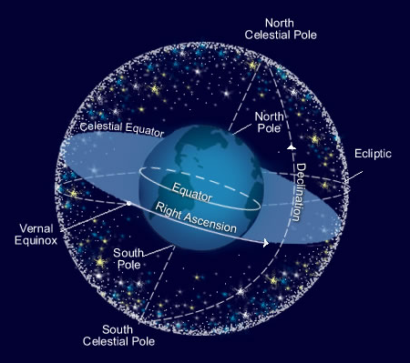
Introduction

Looking up in the night sky, we can see a number of things: stars, planets, our own moon. In very dark skies we might even spy a fuzzy galaxy or two. Sometimes, a transient object (one that doesn't stick around) might appear, such as a comet. If we watch the sky carefully, we'll notice movement on many different time scales. Every 24 hours, the stars appear to rotate around the Earth; the visible constellations change from season to season; the planets appear to wander among the stars. These apparent motions are due to the motion of the Earth and the the other planets as we orbit the Sun. It takes a little imagination to visualize how the apparent motions we see in the sky translate to actual motions in space.

Because the distances to celestial objects are so large, they appear to be imprinted on a two dimensional surface in the night sky. We can imagine this two dimensional surface as a great dome over our heads. If we could remove the Earth, we would be surrounded by a great sphere, known as the celestial sphere. To describe the position and size of objects on the celestial sphere, Astronomers use angular measurements. In this lab, we are going to learn how to measure the angular separation of various objects and develop an understanding of the relationship between angular separation and distance.
Part 1: Measuring angles
Supplies
We are going to learn how to measure angular separation. You will need:
- A clear ruler
- A 1-meter stick
- A 2-meter stick
Step 1: Calibrate your measurements
One way to measure angular separation is to use a clear ruler held between the thumb and forefinger at arms length. Rulers are marked in centimeters and angles have units of degrees, so we need to convert from centimeters to degrees. To perform this conversion we will use the rules of trigonometry, the study of triangles. If the angle is small we can write:

where
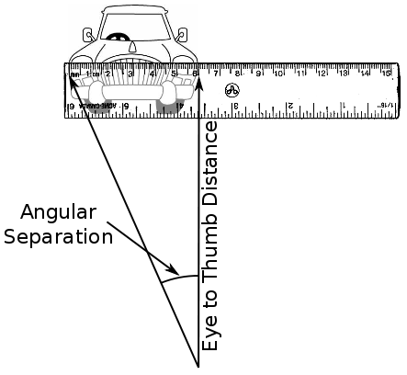Holding a clear ruler at arms length, close one eye and sight down your arm. Place the zero of the ruler on the left edge of the object that you're measuring and read the number at the right edge.

You've made a big triangle! The formula above converts the ruler reading to the labeled angle of the triangle, or the angular distance.

- Take turns measuring each other's Eye to Thumb Distance. To get an accurate measurement, we'll have each one of your group members measure your arm and then calculate the average of the three measurements. Record the results in Table 1 in the answer packet. Repeat this exercise for each member of your group. Everyone should have an average eye to thumb distance recorded in Table 1.

Measuring arm length
Record results in Table 1.

- Use your Average Eye to Thumb distance and the formula above to calculate your Personal Conversion Factor. Record your personal conversion factor on Table 1 in the column labeled PCF. You will need your PCF for the term project, so take a moment RIGHT NOW to record it on your own Term Project Data Sheet.

Step 2: Measure some angles
Let's practice measuring some angles by measuring the Angular Size of a
2-meter stick from several distances.

- Go into the hallway and have one group member hold a 2-meter stick at each of the three distances indicated in Table 2. (Hint: Because these are angles, it doesn't matter if you hold the meter stick upright or horizontally.)

- Holding your ruler at arms length, measure the apparent length of the
2-meter stick in centimeters for each distance.
Record your results in Table 2.

- Repeat steps 1 and 2 until everyone has taken each of the three measurements.

- Use your Personal Conversion Factor to convert the measurements you made in Step 2 from centimeters to angular size in degrees.

Step 3: Answer the questions for Part 1 in the answer packet.
Part 2: The Term Project
In the term project, you will make measurements of the sunset and ultimately compare those measurements to two competing theoretical models. You will use your data to determine which model is the best. To help you make your measurements, we will practice by making practice measurements in the lab room.

Your task is to measure the azimuth of the Sun at sunset at various times throughout the semester. The azimuth is an angle around the horizon increasing clockwise with North at 0^{o.}

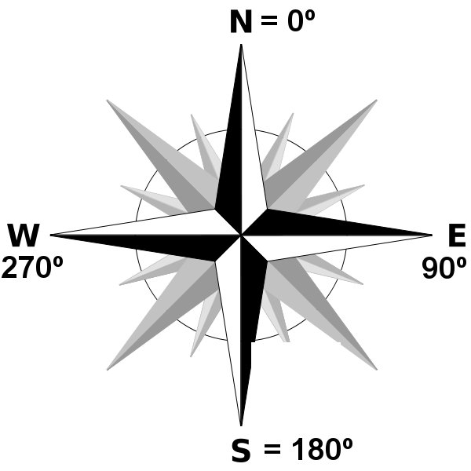
Imagine that we are looking down from directly above at someone standing at the center of the compass rose pictured above. An object directly North of them will have an azimuth of 0º. Because we will be observing sunset, and the Sun generally sets in the West, we will measure the angular separation between the Sun and a landmark that is roughly West and use this angle to calculate the Sun's azimuth.
Looking toward the West, we might see a skyline that looks like this:

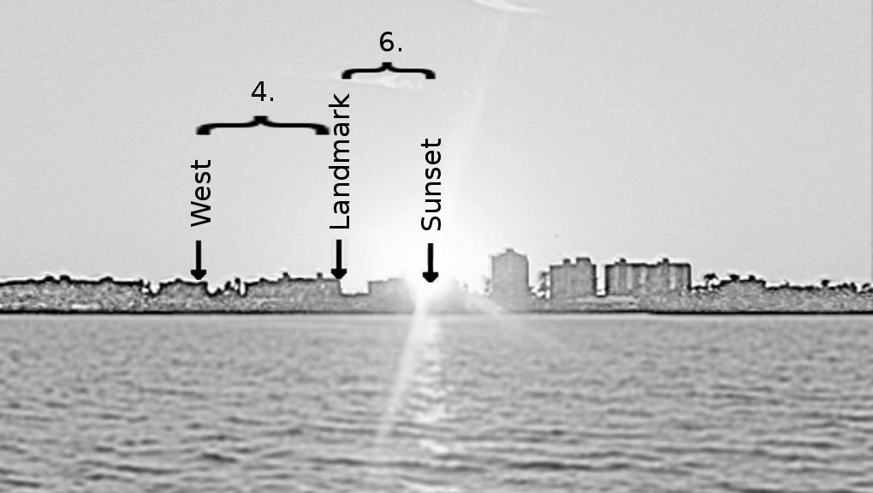

Consistency will gets better results, so we will always take our measurements from the same place. Once we've picked a spot, choose an easily recognizable landmark and always measure the Sun's position with respect to that landmark. We only need to locate due West once so that we can find the landmark's true azimuth and then calculate the Sun's azimuth from that. We will practice with a mock observation so that you can see how this works.
Note: You cannot use this measurement for your project.

At the back of the room are pictures of a few landmarks, the Sun, and West.

Step 1: Answer questions 1-3 in Part 2 of the answer packet.

Step 2: Measuring the Sunset

- Stand in the front of the room and use your ruler to measure the apparent distance (in centimeters) between West and a landmark on the pictures at the back of the room. Make this number negative if it is to the left (South) of West and positive if it is to the right (North) of West. Record your measurements in the Ruler column of Table 3.

- Multiply your Ruler measurement by your Personal Conversion Factor record this number in the Angle column of Table 3.

- Convert Angle to Landmark Azimuth using the following formula:
Azimuth = Azimuth of West + Angle
NOTE: You will need to perform steps 1 through 3 for your actual landmark at your actual observing location.

- Now, use your ruler to measure the apparent distance between your landmark and sunset. Make sure you are standing in the same spot as for your landmark measurement. If the Sun is to the left of your landmark, write down the ruler reading as negative; if to the right it should be positive. Record this number in the Ruler column of Table 4.

- Multiply your Ruler measurement by your Personal Conversion Factor and record this number in the Angle column of Table 3. Be sure to keep the negative or positive sign!

- Calculate the actual Sun Azimuth from your measured Angle and the Landmark Azimuth as follows:
Azimuth = Azimuth of Landmark + Angle
Remember that adding a negative is just subtracting. Record this number in the Azimuth column of Table 4.

- Repeat Steps 1 through 6 for each member of your group.

Step 3: Finish answering the questions in the Answer Packet. Turn in one copy of the Answer Packet for your group.

