Observing Night!

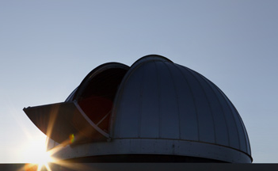
Research in astronomy comes in two flavors: observation and theory. In the lecture hall, we discuss many theoretical ideas. The sunset project, observing night, and the lab exercise where we manipulate our observational data are designed to give you a taste of the observational side of astronomy.

On observing night, we will do two exercises:
- Gather data for a future lab with the robotic telescope in the observatory.
- Observe some bright targets with three different small telescopes.

The UST Department of Physics Observatory is located on the top level of the Anderson Parking Facility.
NOTE: If you have access to the ramp, DO NOT park on the upper deck as your headlights will blind all of us!

You will come to the observatory two lab groups at a time. The observing schedule is posted on the course web page. The start time will depend on what time the Sun sets and the event lasts 1.5 hours total. On arrival, each group will be assigned to one of the two stations. After 45 minutes, you will rotate to the next station.

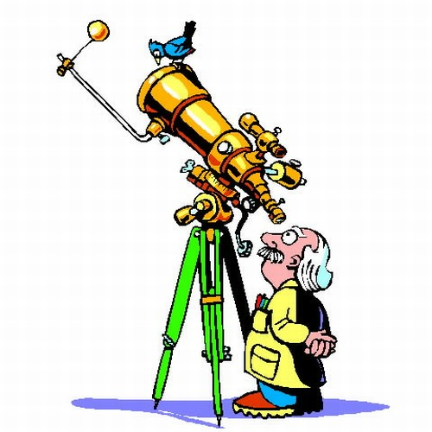
Small Telescope Observing

Part 1:

In this exercise, you will compare the view through the eyepieces of three small telescopes. They are:

- 8” (diameter) telescope with a 40mm (focal length) eyepiece
- 8” telescope with a 12.5mm eyepiece
- 12” telescope with a 40mm eyepiece

All three telescopes will initially be pointed at the same object. Take a look through each of the telescopes. Think about the following questions as you do so:

- In which telescope does the object appear largest? Smallest? (compared to the whole field of view)
- In which telescope does the object appear brightest?
- In which telescope can you see the most detail?
- In which telescope does the object look the best?

Answer the questions in the answer packet.

Part 2:

Use your sky chart to locate the objects listed in the questions packet.

