Optics and Imaging
The purpose of an optical system, telescopes included, is to gather light, manipulate it to examine particular properties such as color or polarization, and then focus onto some sort of detector. The “detector” can be a screen, the retina of your eye, or on an electronic detector like the chip in your digital camera. Galileo's telescope used lenses to gather the light from objects in space. His telescope design incorporates the lens in your eye as the final optical element to ultimately form an image on your retina.
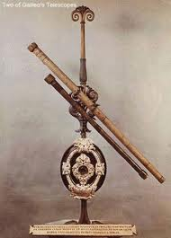Two of Galileo's refracting telescopes
Sir Isaac Newton speculated that sunlight is composed of different colors of light that, when combined, create the “white” light that we see. To prove it, he set up an experiment using two prisms. The first prism spread the sunlight into a rainbow of colors (a spectrum). The second prism recombined the spectrum into the original white sunlight. This prism effect, the separation of light into its component colors, also occurs in lenses, making telescopes with lenses difficult to build. Newton's solution was to use a curved mirror to gather and focus the light instead of a lens. Most large modern telescope uses mirrors as the primary light gathering element.
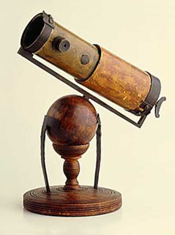Newton's reflecting telescope
In this exercise, we are going to use the prism effect to examine the color theory of light. We will also learn about forming images with lenses and telescope mirrors.
Part 1: Light and Color
The ability to separate light into its component colors is extremely important to astronomers. Many physical processes are understood through the detailed examination of the color of light received from an object. Astronomers use prisms (diffraction gratings really, but that's another lab) and colored filters to separate light into its component colors. The telescope in the observatory uses colored filters in front of a gray scale (black and white) camera. Later in the semester, you'll recombine the images taken through each filter into a full colored image. In this exercise we'll look at filters and prisms to understand how colored light can be broken apart and recombined.
We have set up Newton's double prism experiment for you. The image below shows two configurations. In the left image, a single prism breaks the light apart and projects the resulting spectrum on the “Spectrum” screen. In the right image, the recombining prism has been added and the recombined image is projected onto the “Recombined” screen.
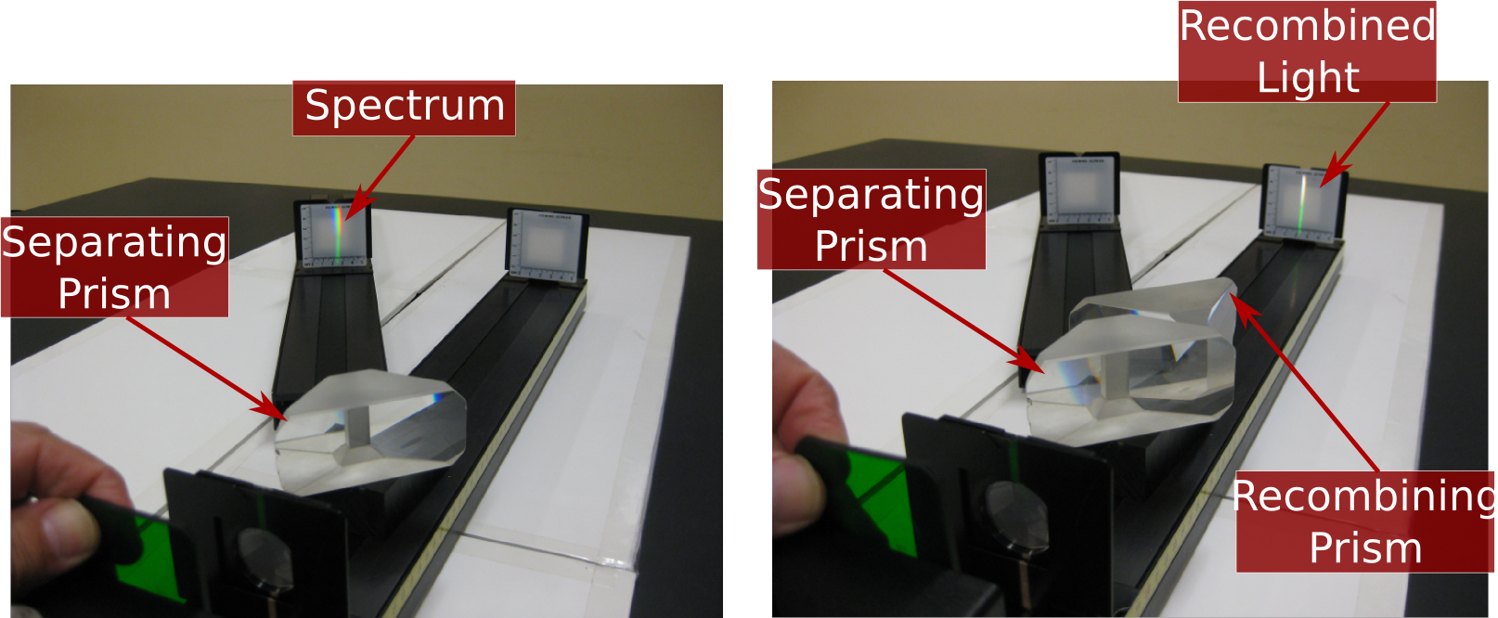
Single Prism Double Prism

Procedure:
You are going to look at transmission properties of five different colored filters that we have provided. Record your results in Table 1 in your answer packet. Filter 0 in the table is pure white light (NO filter).
- Hold the filter so that it blocks half of the slit as shown in the image below (except for filter zero, which is pure white light with NO filter).
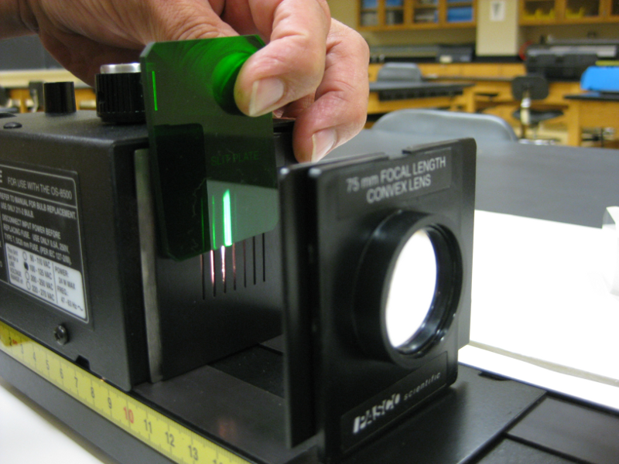

- If the recombining prism is in the light path, remove it. Examine the spectrum and write in Table 1 all of the colors that you can see.
- Put the recombining prism back in place (as shown in the picture on the previous page). Examine the recombined light and write the color that you see in the Table 1.
- Answer the questions in the packet.

Part 2: Images
Lenses (and properly shaped mirrors) have the property that all of the light hitting the lens from a single point on the object is redirected to a single point in the image. In the picture below, three rays of light are shown leaving Gumby's head. Even though each ray hits a different part of the lens, they are all redirected to hit a single point in the image. The image is “out of focus” when the light from a point on the object does NOT hit a single point in the image.
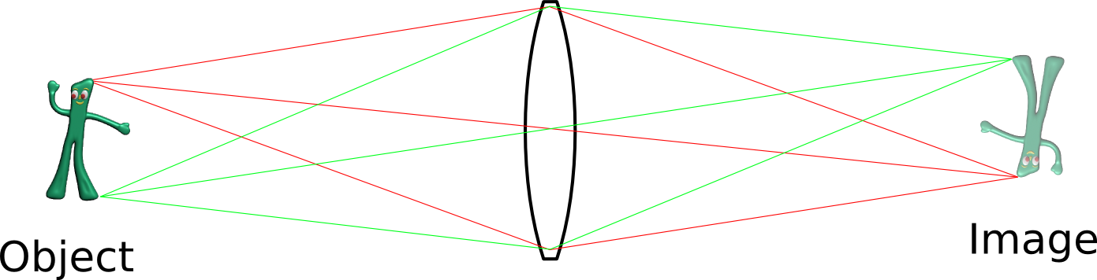
In this exercise, we are going to look at an image formed with a small lens and compare it to an image formed with a small reflecting telescope.
Procedure
- Examine the two images formed by the lens and the telescope on the screen. Answer questions 1 through 3 in the packet.
- Cover EXACTLY half of the lens with a piece of paper. Answer question 4 in the packet.
- Cover EXACTLY half of the telescope opening with a piece of paper. Answer questions 5 and 6 in the packet.

