**Solar Heating**

Introduction

This exercise should help you become familiar with the sky, and introduce you to our relationship to the Sun. We will look at the causes of the seasons based on observations of the sun’s position and motion in the sky *as observed from Earth*. The underlying *cause* of the seasons will be investigated later; in this lab we are just going to work on the observations!

To do this, we will be using a free planetarium program called *Stellarium*.

Setup:

If you have not already done so, boot up your computer. You can log in using your regular UST login. Bring up *Stellarium* using the icon on the desktop. The program automatically assumes a date, time and location. This *should* be set to St. Thomas: Latitude **N45° 30’ 0.00”**, longitude: **W93° 0’ 0.00”**, and altitude of **38 m**. The time should be set to **noon standard time** (if it is currently daylights savings time, set it to 1:00pm.) The location and time menus can be found by placing your cursor near the left side of the screen if they are not set correctly.

Part 1: The Sun in the Sky at Noon

1. We’re in St. Paul Minnesota, it’s close to noon, and we turn to face the Sun.
   1. What direction would you expect to be facing? Why?
   2. In the program, find the direction are we actually facing:
   3. Why is the Sun in that direction?

1. Does everyone on Earth see the sun to the south at their local (standard) noon? Why or why not?

Below two students are arguing about where the sun must be at noon:

*Student 1: If it’s winter the sun doesn’t go as high in the sky, so it’s only straight overhead in summer. In the winter it must be closer to the horizon, halfway between east and west. That means it will be in the southern half of the sky, but above the horizon.*

*Student 2: I think you are almost right, but what if we are in the Southern Hemisphere? Then the sun will be to the north, not the south.*

*Student 3: Neither of you are correct. Everyone knows the sun is always overhead at noon. So, if I look straight up at noon, I should see the sun. It might be a little to the east or west if I’m not at the center of my time zone, but it should be pretty much straight up.*

1. Do you agree with Student 1, Student 2, or Student 3? Explain why:

Let’s turn on a coordinate system to help us answer this question. Move your mouse to the lower part of the screen. A menu should pop up. In it, there should be something that looks like a globe, and next to it something that looks like a target. Click on the target, which is the **azimuthal grid**.

Azimuthal grid

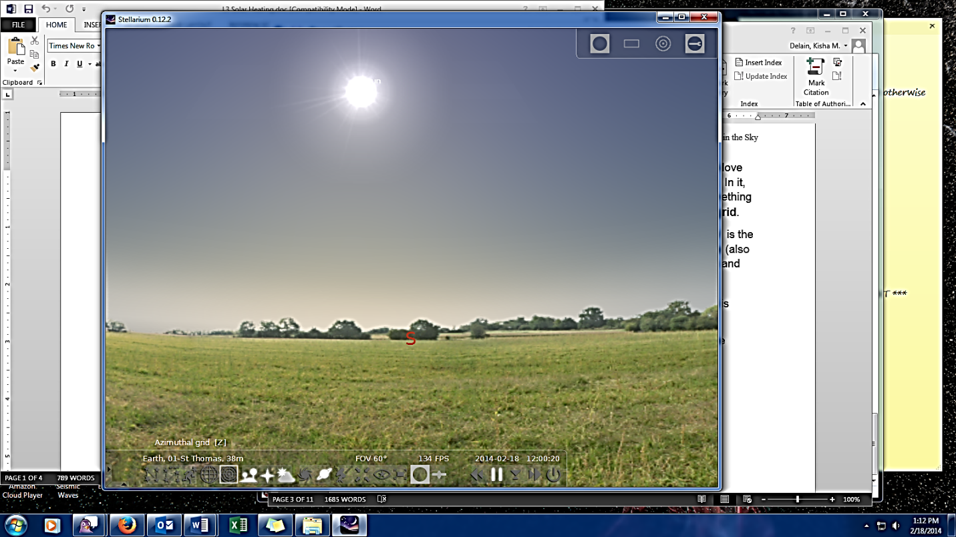

This grid gives us two coordinates: **Azimuth** and **Altitude**. Altitude[1] is the angle (in degrees) above or below the horizon. Azimuth is the angle (also in degrees) around the horizon starting with zero degrees due north and going around clockwise (so that due east is 90°).

The **zenith** is the point directly overhead, at an altitude of 90°. This is where all of the lines of azimuth converge.

1. Does everyone have the same zenith? Why or why not?
2. Click and drag so that you can see the zenith. Is the sun at the zenith? Does this change your answer to #3?

There is a second menu on the left side of the screen, in the bottom half. Move your cursor until that menu opens. Mouse over the different options to see what is available.

1. Drag the sun back into view. Bring up the location window (at the top) and move it to the side so you can see the sun. Trying to keep at the same *longitude*, click at different *latitudes* (north or south of St Thomas). How does this change the altitude of the sun at noon?
2. Is there a location where the sun will be directly overhead at noon today? Click around until you find it the latitude of this location and write it below:
3. Do you think that the sun will be directly overhead at this location in winter? Why or why not?
4. What latitude is the sun overhead on the winter solstice? The summer solstice? What do you think is special about these latitudes?

*Your instructor will do a demonstration before answering the next questions*

1. Thinking back to our demonstration with the flashlight, and how the angle of incidence affects **beam spreading**, what is one reason temperature is affected by a person’s latitude? Include a diagram for Northern Hemisphere summer, and another diagram for Southern Hemisphere summer.
2. What do your observations suggest about beam spreading in winter vs. summer?

Part 2: The Sun’s Altitude & Length of Day

Make sure you are back in St. Paul by clicking on the “return to default” in the location window. You can close the location window when you are done. Open the Date/Time window from the left menu and **change the date to mid-June**. Let’s now look at the motion of the sun at sunset.

1. Which direction do you think you must look (roughly) to see the sun setting? Drag the screen so that you are looking in that direction (and write the answer here).
2. Pull up the time window and click the clock forward until the sun sets. Which direction does the sun actually set? (If you are having a hard time seeing the sun for the trees, feel free to turn off the horizon in the menu at the bottom.)
3. Which direction would you expect the sun to set mid-winter? Change the date to mid-December and check. Write your expectations and findings below:

Now look at the motion of the sun as it sets (say an hour before to sunset).

1. Does the sun set straight down to the horizon? In other words, is its motion perpendicular to the horizon? Describe its motion here:
2. Does the sun spend a long time or a short time near the horizon?
3. Change the date to summer. Does that change the motion & length of time as the sun sets?

The sun’s light has to go through more atmosphere when it is close to the horizon compared to when it is higher in the sky. This means less light (and particularly less of the higher energies) reach us.

1. What do your observations of the sun’s motion at sunset suggest about the affect the atmosphere has on solar heating in winter vs. summer?

Part 3: Length of Day

There’s one more useful definition when talking about motions of objects in the hemisphere of sky we can see. The **meridian** is an imaginary line through zenith extending from North to South. A celestial object is at its highest point in the sky when it crosses the meridian, and the meridian is halfway between rising and setting.

* Turn the meridian on by going to “Sky and Viewing Options” in the left menu and clicking on the tab “Markings”. Click the check box next to Meridian.
* Return the date and time to Summer Solstice at noon (standard time), and look due south. Change the time to get the sun directly on the meridian. Record this time in the table.
* Run the clock forward until the sun sets and record that time in the table.
* Change the date to an equinox, and record the times on meridian to sunset in the table.
* Next, change the date to Winter Solstice, recording the times again.
* Calculate the length of the day. Remember that this is TWICE the time from meridian to sunset!

|  |  |  |  |
| --- | --- | --- | --- |
| **Date** | **Sun on Meridian** | **Sunset** | **Length of Day** |
|  |  |  |  |
|  |  |  |  |
|  |  |  |  |

1. How long is the sun up on the equinox? What does this mean about the length of heating (daytime) vs. cooling (nighttime)?
2. How does the length of day at summer solstice compare to the winter solstice? Discuss the implications for the seasons.
3. What are the three main reasons for the seasons, based on your **observations**?
4. You observed the sun as viewed from Earth. What is the *physical* *cause* for these observations? In other words, what’s really going on?

**Vocabulary**

**Zenith**: The zenith is the point on the celestial sphere that is directly overhead.

**Horizon**: The horizon is a “line” on the celestial sphere where each of its points is exactly 90° from the zenith (this means we’re ignoring things like trees, and if we lived someplace like Colorado, mountains.). Objects above the horizon can be seen. Those below the horizon can not.

**Meridian**: The meridian is the vertical circle that passes through the celestial poles (also the north and south points) and the zenith.

**Altitude**: The altitude of an object is equal to the angle, in degrees, measured directly up from the horizon to the object. The range of altitudes is +90° to -90°.

**Azimuth**: The azimuth of an object is the angle, in degrees, from the north point *along the horizon*, to the point where the object is (drop down a line along the celestial sphere to the horizon to find this spot). This angle increases to the right and the range of azimuth is 0° to 360°.

**Latitude**: Your position on Earth is given in terms of latitude and longitude. For this lab, only your latitude will matter. Your latitude measures your angular distance along the Earth’s surface from the equator. The latitude of the Twin Cities as 45°.

**Longitude**: Your position on Earth East or West of the Prime Meridian, which is chosen to go through Greenwich, England. Our longitude is West 93°.

1. In some fields of study, this is called “solar angle”.