The View From Earth
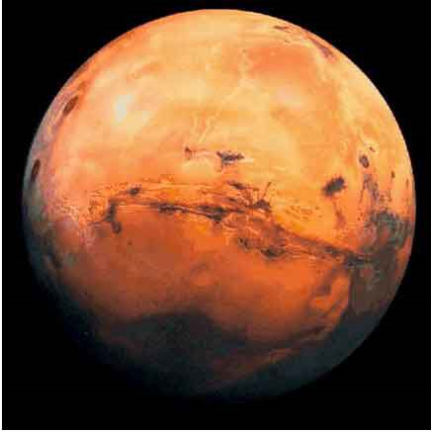
Introduction

Some newspapers and science magazines, such as Sky and Telescope, provide sky charts that describe what sky objects are visible at different times. These typically include prominent stars, bright planets, and the Moon. There are two principle maps provided to readers: (1) a geocentric horizon view and (2) a heliocentric orrery view. The geocentric perspective is the view from Earth looking up into the southern sky. The heliocentric perspective is the view of the Solar System looking down from above. From above the north pole, the planets orbit and spin counter-clockwise (except Venus, which spins backwards, but we'll forgive it for that).

Once we know how we see things in the sky, we can try to use those ideas to figure out how they move. Kepler said that, to discover the secret of the cosmos, we must use the motion of Mars; “otherwise, it would remain eternally hidden.” He had the goal of developing an accurate mathematical description of the motions of the planets, a goal that he did eventually achieve. However, first he needed to determine exactly what those motions were and, unlike most astronomers before him, Kepler chose to look only at data to answer this question without relying on any underlying philosophical models. The relatively large eccentricity of Mars' orbit makes its elliptical shape relatively easy to study. In this lab, we will first try to visualize things in the sky, and then determine Mars' orbit.
Part 1: Rising and Setting Times

As seen from above the north pole, Earth appears to rotate counterclockwise. Figure 1a in the answer packet shows a top view of Earth and an observer at noon. Note that our Sun appears overhead at noon when standing at the equator.

- In Figure 1a (in the answer packet), sketch and label the positions of the observer at midnight, 6 pm (sunset) and 6 am (sunrise).

- Consider Figure 1b (to the right), which shows Earth, Moon, Mars, and Venus. At what time would each of these sky objects be overhead? Remember that Earth spins counter-clockwise when viewed from above. [Hint: Make use of Figure 1a]
Figure 1b: Orrery

Write your answer in Table 1

- If Earth spins once in 24 hours, that means that each sky object is visible for about 12 hours. What time will the sky objects shown in Figure 1b rise and set? Write your answers in Table 1. Each member of your team should fill in the data for one sky object.

- Answer question 1 in the packet.

Part 2: Converting Geocentric to Heliocentric

Figure 2a

- Figure 2a shows the horizon view of the first quarter Moon and Saturn visible at sunset. On the orrery shown in Figure 2b, sketch and label the position of Jupiter, Moon and Saturn. Use an arrow to indicate the direction to our Sun. Start by indicating the position of the observer at sunset.

- After completing the diagram, fill in the rise and set times in Table 2.

- Answer question 2 in the packet.

Part 3: Converting Heliocentric to Geocentric

- Figure 3a shows the position of Mercury, Venus, Earth, Mars, and Moon. On the horizon diagram, Figure 3b, sketch and label the positions of Mercury, Venus, Mars, a comet, and Moon at midnight.
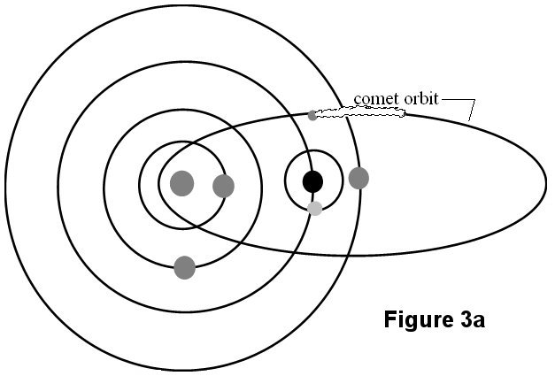

- Answer question 3 in the packet.
Part 4: Mapping Mars’ orbit
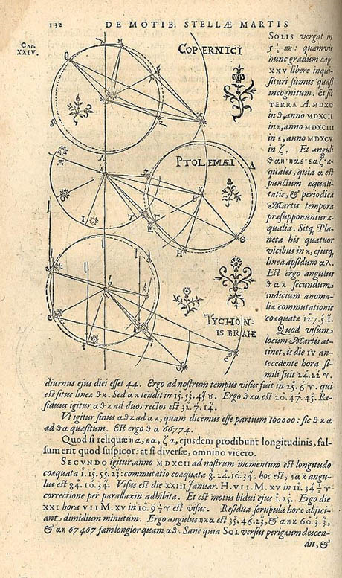A page from Kepler's book Astronomiae Nova (A New Astronomy) illustrating his method for determining the orbit of Mars.
Kepler developed a particularly clever geometrical method to establish Mars' orbital path. He knew that the period of Mars' orbit is 687 days while the period of Earth's orbit is only 365 days. Hence, if Mars were observed at a particular point in its orbit, it would be back at the same spot in 687 days, but the Earth would not have completed its second revolution. Mars could therefore be sighted from a slightly different vantage point. Using triangulation, the precise position of Mars with respect to the Earth and Sun can be determined.

Although the Martian orbit has an appreciable eccentricity, it is a mistake to think of its shape as an obvious ellipse. It looks much more like a circle that is oddly off-centered from the Sun. In this exercise we will investigate the elliptical nature of Mars' orbit by employing some data from Tycho Brahe and following the method invented by Kepler in the early 1600's.

For this exercise we will need:
- a protractor
- a centimeter ruler
- a compass
- a piece of graph paper.
Procedure
- Find the center of your graph paper. This is the location of the Sun.

- Using your compass, draw a circle with a radius of five centimeters. This circle represents the Earth's orbit.

- Draw a line parallel to the bottom edge of the paper from the Sun to the right-hand edge of the graph paper. This represents the direction of the Sun as seen from Earth at the time of the vernal equinox.

- Center the protractor on the Sun and align it so that the vernal equinox line is at 0°. Now mark off the heliocentric longitude of the Earth on each date in Table 3 and label the date.
**Be sure that the angles are increasing counterclockwise**

- Next, for each observation in Table 3, center the protractor on the Earth and align 0° in the direction of and parallel to the vernal equinox and mark off the geocentric longitude of Mars. Draw a straight line from Earth in the observed direction of Mars.
**Be sure that the angles are increasing counterclockwise**

- For each pair of observations, the position of Mars lies at the intersection of the lines drawn in Step 5. Mark these with a dot.
Table 3: Kepler's Data
Date | Heliocentric Longitude of Earth | Geocentric Longitude of Mars
Feb. 17, 1585 | 159° 23' | 135° 12'
Jan 5, 1587 | 115° 21' | 182° 08'
Sept. 19, 1591 | 5° 47' | 284°18'
Aug. 6, 1583 | 323° 26' | 346° 56'
Dec 7, 1593 | 85° 53' | 3° 04'
Oct 25, 1595 | 41° 42' | 49° 42'
Mar 28, 1587 | 196° 50' | 168° 12'
Feb 12, 1589 | 153° 42' | 218° 48'
Mar 10, 1585 | 179° 41' | 131° 48'
Jan 26, 1587 | 136° 06' | 184° 42'

- Kepler chose perihelion and aphelion as the first two sets of observations. A line connecting them (and intersecting the Sun) represents the major axis of the orbital ellipse (the semi-major axis is half this). Draw the best possible line connecting these three points and mark its midpoint on your graph.
- Using your compass, approximate the orbit of Mars by drawing a circle centered at the midpoint of the semi-major axis. Using simple ratios, find the length of the semi-major axis of Mars' orbit in AU (Astronomical Units). Record this number in the lower left corner of your diagram.
- The eccentricity, e, of the orbit is:

Calculate the eccentricity (make sure to convert the Sun to Midpoint distance to AU) and record it in the lower left corner of your diagram.

- Answer the questions in the packet

