The View From Earth

Turn in one copy of this answer packet with each group member's printed name and signature. By signing, you certify that you have actively participated in the exercise and have put forth effort in equal share to your fellow group members.

Printed Name Signature

______________________ _____________________

______________________ _____________________

______________________ _____________________

______________________ _____________________

Part 1: Rising and Setting Times
Figure 1a: Observer Positions on Earth
(Observer is at Equator)

Table 1: Celestial Times
Sky Object | Rise Time | Time Overhead | Set Time
Sun
Venus
Moon
Mars

- Using complete sentences, explain why our Sun is not visible at midnight. Add a sketch of Earth, Sun, and observer in the space provided to support your explanation.

Part 2: Converting Geocentric to Heliocentric

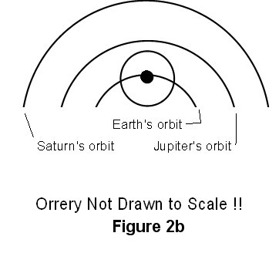

Table 2: Rise and Set Times for Figure 2a
Sky Object | Rise Time | Set Time
Sun
Jupiter
Moon
Saturn

- If Neptune is visible overhead in the southern sky at sunrise (6 am) sketch the relative positions of Sun, Earth, Neptune, and observer in an orrery in the space below.

Part 3: Converting Heliocentric to Geocentric

- Venus is often called the morning star or the evening star. Why is it never seen at midnight?

Part 4: The Orbit of Mars

- From your map, estimate the radius of Mars’ orbit in Astronomical Units. (Hint: Measure the approximate radius of Mars’ orbit and divide that by the approximate radius of Earth’s orbit).

- What is the minimum distance between Mars and the Earth in AU?

- In the orbit you have drawn, there is no epicycle evident. Why not?

- Why does the closest opposition of Mars always occur in August?

- What is the heliocentric longitude of Mars at perihelion? At aphelion?

