Spectroscopy

Turn in one copy of this answer packet with each group member's printed name and signature. By signing, you certify that you have actively participated in the exercise and have put forth effort in equal share to your fellow group members.

Printed Name Signature

______________________ _____________________

______________________ _____________________

______________________ _____________________

______________________ _____________________

Part 1: Lab Spectra

Wavelength: Read the wavelength in nanometers from your spectroscope

Table 1: Hydrogen Calibration
Hydrogen,  Observed | 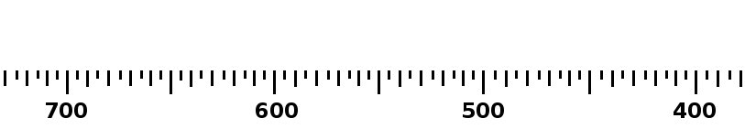
Hydrogen, Calibration

Table 2: Hydrogen Wavelengths & Frequencies
Color | Wavelength | Frequency

(Note: There are four lines, but one is really faint. If you can't see it, that's ok!)

Table 3: Observed Spectra
Blackbody
Fluorescent

Table 4: Emission Line Spectra
Mercury
Neon
Mystery Gas

- How many colors are actually in a blackbody spectrum?

- Do you think any of the gases you observed (H, He, Ne, Mystery Gas) are in the fluorescent light? If so, which one(s)?

- What is the mystery gas?

Part 2: Stellar Spectra

Table 4
Star | λ_{max}  (nm) | Color | T_{surface}  (K) | Spectral Class
The Sun |  |  | 5,800 K
Vega |  |  | 11,000 K

