Term project: "Measuring the Sunset"
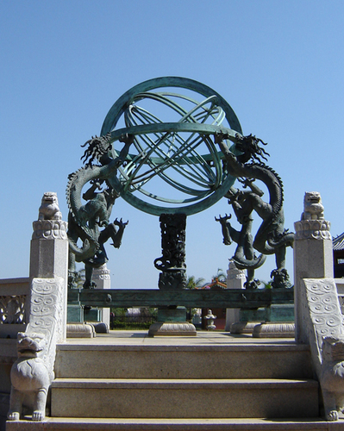
Introduction

Science progresses by making careful observations of nature, developing a working hypotheses that describes the observed phenomena, using that hypothesis to make predictions about nature, and finally querying nature again to test the predictions. If nature agrees with the predictions, the hypothesis gains support. If the hypothesis gains enough support, it may be elevated to the status of scientific theory. However, if nature disagrees with the predictions, the hypothesis must either be revised or scrapped. As scientists, we believe that, over time, the nature of the entire universe can be uncovered through application of these methods.

An observation that has been made is that the Sun sets at different locations on the horizon at different times of the year. We are going use a theoretical model of the Earth/Sun system to predict the exact location of sunset. Over the course of the semester, we will measure the azimuth of sunset and track how it changes over time. Towards the end of the semester, we will compare our observational data to the theoretical values provided by a mathematical model. The mathematical model comes from our hypothesis that the Sun is at the center of the Solar System, the Earth is in orbit around it, and further, the Earth's rotational axis is tilted with respect to the plane of its orbit.

Procedure: Making an observation
!!!NEVER LOOK DIRECTLY AT THE SUN!!!
1. Pick a location that gives you a clear view of the western horizon. Your data will be better if you use the same location for each observation.

2. Find west using a compass or a local street that you are positive runs east/west.

3. Pick a landmark on the horizon that is as close to due west as possible. Use this landmark every time you observe so that you don't have to relocate west for every observation.

- Using your ruler, measure the angle (in centimeters) between due west and your landmark. Calculate the Azimuth of your landmark (see steps 8 and 9 for more details. In this case the number is negative if it is to the left of WEST). Record this number on your data sheet. You only need to do this once.
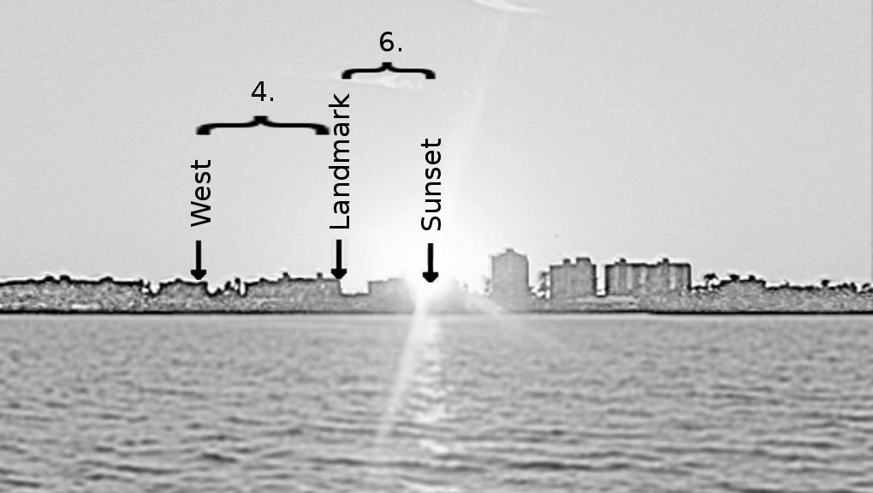
5. To make an observation of sunset, wait until it has just sunk below the horizon, noting its final position. DO NOT LOOK DIRECTLY AT THE SUN.

6. Use your ruler to measure the angle between your landmark and sunset. You will do this for every observation.

- Use the sheet provided on the web page (an example appears here) to record your observation including the date, time, ruler reading, and comments about the current conditions (cloudy, clear, hazy etc.) If the sun is to the left of your landmark, write down the ruler reading as negative; if to the right it should be positive.

- Calculate the Angle from your ruler reading by multiplying by your Personal Conversion Factor (from Lab 1: Measuring the Sky). Be sure to keep the negative or positive sign! Record this number in the Angle column of your data sheet.

- Calculate the actual Azimuth from your measured Angle and the Azimuth of your Landmark as follows:
Azimuth = Azimuth of Landmark + Angle
Remember that adding a negative is just subtracting.
Record this number in the Azimuth column of your data sheet.

- Plot your data on both the HelioCentric: Tilted Earth plot and on the GeoCentric: Great Turtle plot.
Julian Day Numbers
 | Jan | Feb | Mar | Apr | May | Jun | Jul | Aug | Sep | Oct | Nov | Dec
1 | 1 | 32 | 60 | 91 | 121 | 152 | 182 | 213 | 244 | 274 | 305 | 335
2 | 2 | 33 | 61 | 92 | 122 | 153 | 183 | 214 | 245 | 275 | 306 | 336
3 | 3 | 34 | 62 | 93 | 123 | 154 | 184 | 215 | 246 | 276 | 307 | 337
4 | 4 | 35 | 63 | 94 | 124 | 155 | 185 | 216 | 247 | 277 | 308 | 338
5 | 5 | 36 | 64 | 95 | 125 | 156 | 186 | 217 | 248 | 278 | 309 | 339
6 | 6 | 37 | 65 | 96 | 126 | 157 | 187 | 218 | 249 | 279 | 310 | 340
7 | 7 | 38 | 66 | 97 | 127 | 158 | 188 | 219 | 250 | 280 | 311 | 341
8 | 8 | 39 | 67 | 98 | 128 | 159 | 189 | 220 | 251 | 281 | 312 | 342
9 | 9 | 40 | 68 | 99 | 129 | 160 | 190 | 221 | 252 | 282 | 313 | 343
10 | 10 | 41 | 69 | 100 | 130 | 161 | 191 | 222 | 253 | 283 | 314 | 344
11 | 11 | 42 | 70 | 101 | 131 | 162 | 192 | 223 | 254 | 284 | 315 | 345
12 | 12 | 43 | 71 | 102 | 132 | 163 | 193 | 224 | 255 | 285 | 316 | 346
13 | 13 | 44 | 72 | 103 | 133 | 164 | 194 | 225 | 256 | 286 | 317 | 347
14 | 14 | 45 | 73 | 104 | 134 | 165 | 195 | 226 | 257 | 287 | 318 | 348
15 | 15 | 46 | 74 | 105 | 135 | 166 | 196 | 227 | 258 | 288 | 319 | 349
16 | 16 | 47 | 75 | 106 | 136 | 167 | 197 | 228 | 259 | 289 | 320 | 350
17 | 17 | 48 | 76 | 107 | 137 | 168 | 198 | 229 | 260 | 290 | 321 | 351
18 | 18 | 49 | 77 | 108 | 138 | 169 | 199 | 230 | 261 | 291 | 322 | 352
19 | 19 | 50 | 78 | 109 | 139 | 170 | 200 | 231 | 262 | 292 | 323 | 353
20 | 20 | 51 | 79 | 110 | 140 | 171 | 201 | 232 | 263 | 293 | 324 | 354
21 | 21 | 52 | 80 | 111 | 141 | 172 | 202 | 233 | 264 | 294 | 325 | 355
22 | 22 | 53 | 81 | 112 | 142 | 173 | 203 | 234 | 265 | 295 | 326 | 356
23 | 23 | 54 | 82 | 113 | 143 | 174 | 204 | 235 | 266 | 296 | 327 | 357
24 | 24 | 55 | 83 | 114 | 144 | 175 | 205 | 236 | 267 | 297 | 328 | 358
25 | 25 | 56 | 84 | 115 | 145 | 176 | 206 | 237 | 268 | 298 | 329 | 359
26 | 26 | 57 | 85 | 116 | 146 | 177 | 207 | 238 | 269 | 299 | 330 | 360
27 | 27 | 58 | 86 | 117 | 147 | 178 | 208 | 239 | 270 | 300 | 331 | 361
28 | 28 | 59 | 87 | 118 | 148 | 179 | 209 | 240 | 271 | 301 | 332 | 362
29 | 29 |  | 88 | 119 | 149 | 180 | 210 | 241 | 272 | 302 | 333 | 363
30 | 30 |  | 89 | 120 | 150 | 181 | 211 | 242 | 273 | 303 | 334 | 364
31 | 31 |  | 90 |  | 151 |  | 212 | 243 |  | 304 |  | 365

Physics 104 (Astronomy) - Sunset Data Sheet

Name: __________________ Personal Calibration: _____ Az. of Landmark_____

Date | Time | Ruler | Angle | Azimuth | Comments

Raw Data- Not corrected for Azimuth Offset

