Part 3- The Sun's Coordinates

The sky, from our perspective, is two dimensional. To locate an object on a two dimensional surface, we need two numbers or coordinates. On this piece of paper, our coordinates might be the horizontal and vertical distance from the lower left corner. On the celestial sphere, however, we use angles.

Because we're stuck to the Earth's surface, it feels natural to measure positions with respect to our local horizon. An object's height above the horizon is its altitude. The horizon is at 0⁰ degrees and zenith is at 90⁰. Direction (North, South, East, West) is called azimuth. North is 0⁰, East is 90⁰, South is 180⁰, and West is 270⁰.
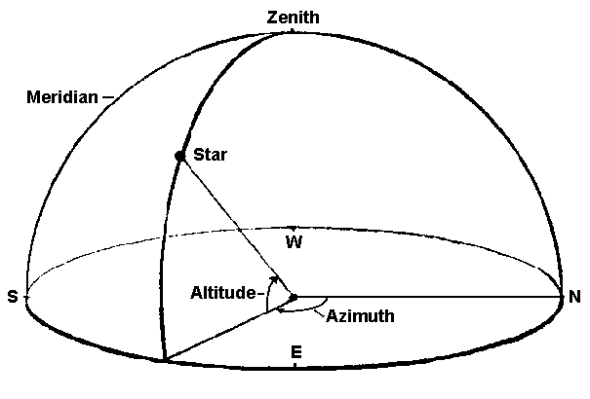

The altitude and azimuth of a given celestial object is not fixed. The altitude of Polaris is 90⁰ at the North Pole but 0⁰ at the equator. In St. Paul, the Sun is low in the East in the morning, high in the South at noon, and low in the West in the evening.

We need a coordinate system that is fixed to the sky. Astronomers use a system whose axis are parallel to the lines of longitude and latitude on the Earth. The lines of latitude are called lines of declination. The lines of longitude are called right ascention. The Celestial Equator is 0⁰ declination and the North Celestial Pole is 90⁰ declination. Right ascension is 0⁰ at the position of vernal equinox and increases Eastward.
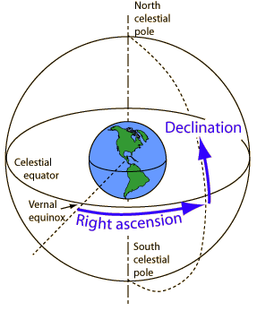
Because the Earth's axis is tilted 23⁰ with respect to the ecliptic, the Sun's declination changes throughout the year. This means that the Sun's altitude at meridian as well as its azimuth at sunset change throughout the year. Assume that you're in St. Paul (44⁰ North Latitude) and use the picture below as a guide to complete the following table:

Date | Declination | Altitude at Meridian | Sunset Position
Vernal (spring) equinox (March 21st) |  |  | Due West
Mid-May  (approximately) | 12⁰
Summer Solstice  (June 21st) | 23⁰
Autumnal equinox (September 22nd) |  | 44⁰
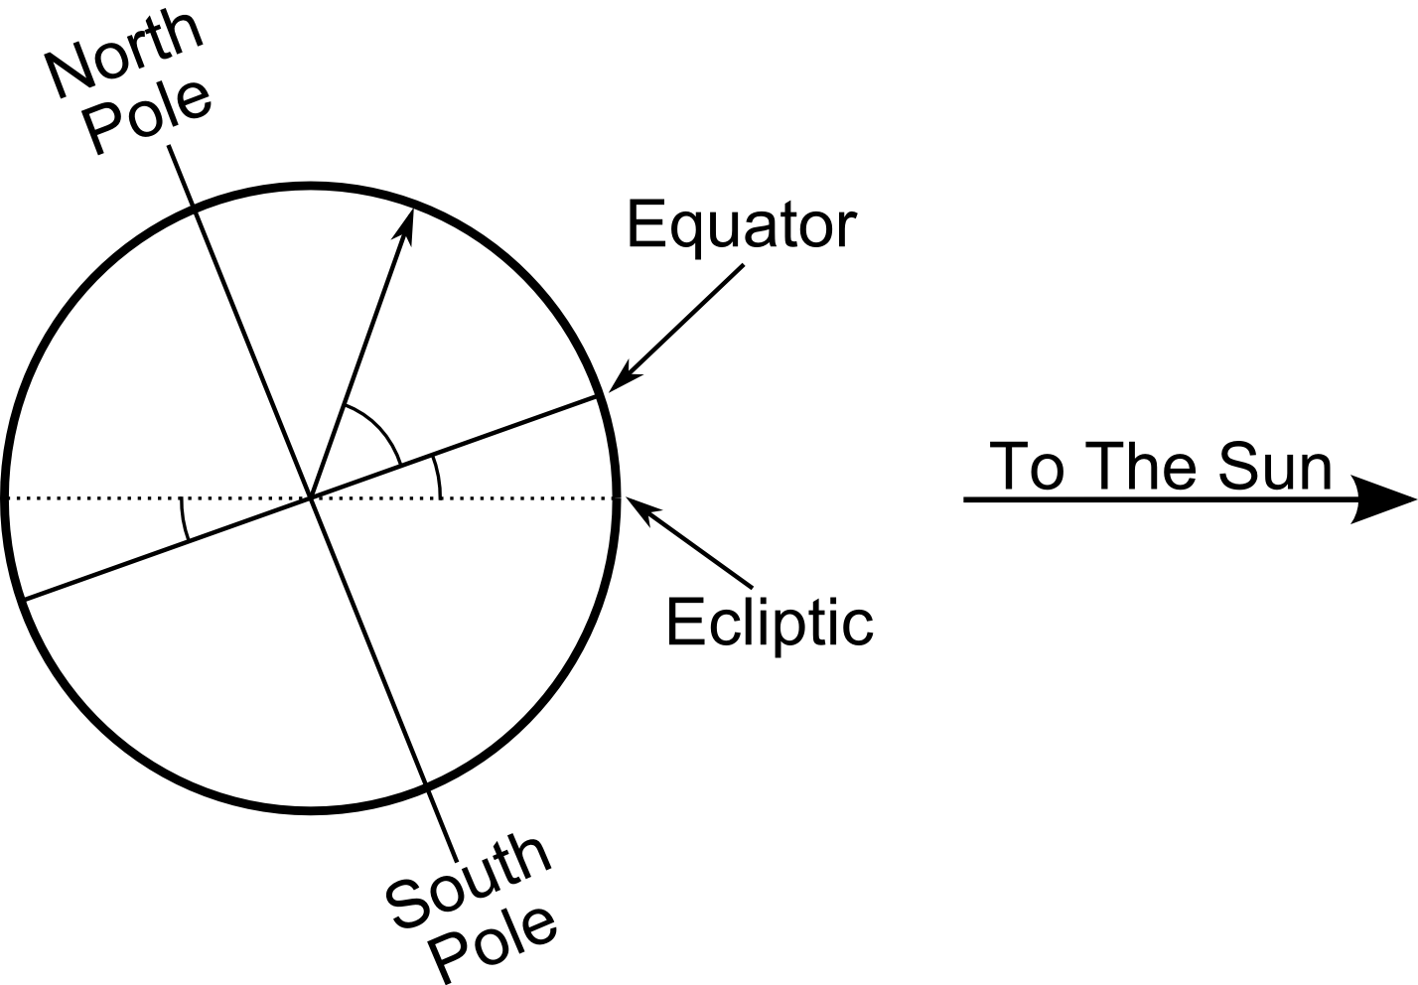  Mid-November (approximately) |  | 32⁰
Winter Solstice  (December 21st) |  |  | South of West

